DRAFT FINAL

ExxonMobil Technology and Engineering

Geohazard Management Program

Program Manual

Asset Integrity Guidelines for Pipeline Operations Management

Version 2.0 | March 2025

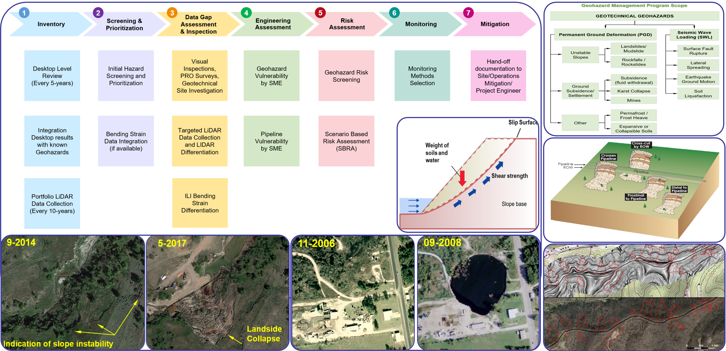

Revision Record

|  |  |  |  |
| --- | --- | --- | --- |
| Version No. | Date Issued | Reviewed By | Description |
| 1.0 | 02.2021 | EMPCo | Initial release |
| 1.1 | 10.2023 | EMPCo  R. Landazuri | Complete revision throughout document |
| 1.2 | 11.2024 | EMPS  Roberto Landazuri  Steven Bevers | Complete rewrite to mirror Water Crossing Program (WCP) Stages, integrate legacy Denbury GMP, and incorporate API 1187 recommendations as applicable. |
| 2.0 | 03.2025 | EMTech  Svetlana Shafrova  Patrick Lee | Enhanced for Global ExxonMobil (XOM) use consistent with latest WCP Manual. Updated references to publicly available datasets, dashboards, monitoring portals including susceptibility hazards maps leveraging the latest releases available for use. Added additional information for Upstream Sites such as Germany, Indonesia, PNG, and Guyana as applicable. |
|  |  |  |  |

Program Effectiveness

The effectiveness and relevance of the Geohazard Management Program (GMP) to global pipeline integrity health is maintained through program/process reviews stewarded by ExxonMobil Technology and Engineering (EMTech), including guidelines, manuals, procedures, tools updates and enhancements of analyses methodology based on new data or/and industry findings, lessons learned and feedback on GMP deliverables, efficiency and effectiveness.

Relevance

This manual describes the significance of the GMP and provides a brief overview of execution. Roles and responsibilities are also discussed.

Contents

Contents iii

Executive Summary I

1 Introduction 4

1.1 Purpose, Objectives and Scope 4

1.2 Geohazards Threats 8

1.3 Program Application 11

2 GMP Workflow Process 13

2.1 Stage 1 – Inventory 15

2.1.1 Existing Pipelines 16

2.1.2 New Built Pipelines 17

2.1.3 Ground and Aerial Reconnaissance 18

2.1.4 Inventory Stewardship 19

2.2 Stage 2 - Screening and Prioritization 22

2.2.1 Hazard Screening and Prioritization 22

2.2.2 Bending Strain Data Integration and Response 24

2.3 Stage 3 - Data Gap Assessment and Inspection 26

2.3.1 Remote Sensing Data 27

2.3.2 Site Specific Data 29

2.3.2.1 Ground Reconnaissance 29

2.3.2.2 Geotechnical Methods 30

2.3.2.3 Geophysical Methods 31

2.4 Stage 4 – Engineering Assessment 32

2.4.1 Geotechnical Vulnerability Models 33

2.4.1.1 Overview 33

2.4.1.2 Geological Study or Survey 34

2.4.1.3 Geotechnical Investigation 34

2.4.1.4 Tectonic or Seismicity Study 34

2.4.1.5 Seismological Study 35

2.4.2 Pipeline Vulnerability Assessment 35

2.4.2.1 Overview 35

2.4.2.2 Stress-Based vs. Strain-Based Design 35

2.4.2.3 Estimating the Level of Stress or Strain Demand 36

2.4.2.3.1 Permanent Ground Deformation Loading 36

2.4.2.3.2 Soil Spring Models 36

2.4.2.3.3 Soil Continuum Models 37

2.4.2.3.4 Seismic Wave Propagation Loading 37

2.5 Stage 5 - Risk Assessment 39

2.6 Stage 6 - Monitoring 41

2.6.1 Scheduled Monitoring 42

2.6.2 Trigger Monitoring 42

2.7 Stage 7 - Mitigation 44

3 GMP Roles and Responsibilities 45

4 Data Management 48

4.1 Quality Control and Quality Assurance (QA/QC) 48

4.2 Documentation 48

5 Program Effectiveness 49

5.1 Review Process 49

5.2 Program Updates 49

5.3 Performance Measures 49

Acronyms and Abbreviations 50

Internal References 59

External References 60

Appendixes

Appendix A. Geohazard Management Program RACI

**Appendix B. Introduction to Geohazard Threats**

Appendix C. Hazard Classification

Appendix D. Bending Strain Data Integration

Appendix E. Level 2 Geohazards Investigations

**Appendix F. Slope Stability Assessment Manual**

**Appendix G. Geohazard Monitoring Methods**

**Appendix H. Geohazard Mitigation Guidelines**

Tables

Table 1‑1. Brief Geohazard Management Program Toolkit 6

Table 2‑1. Minimum Geohazard Inventory Information 20

Table 5‑1. Geohazards Management Program Score Card 49

Figures

Figure ES‑1. General Geohazard Management Program Workflow (Stages 1 – 7) 2

Figure 1‑1. Geohazard Threats addressed by Water Crossing & Geohazard Management Programs 9

Figure 1‑2. Examples of Typical Geotechnical Hazards 10

Figure 2‑1. Geohazard Management Program Workflow Stages and Process Steps 14

Figure 2‑2. GMP Stage 1 – Inventory 15

Figure 2‑3. Conceptual Examples of Distance Relationships Between Geohazards and Pipeline 21

Figure 2‑4. GMP Stage 2 – Screening and Prioritization 22

Figure 2‑5. GMP Stage 3 – Data Gap Assessment and Inspection 27

Figure 2‑6. Example of LiDAR Geohazard Assessment 28

Figure 2‑7. Comparing Inactive vs. Active Geohazards 30

Figure 2‑8. GMP Stage 4 – Engineering Assessment 32

Figure 2‑9. Driving and Resisting Forces of Slope Equilibrium 33

Figure 2‑10. Idealized Representation of Soil with Discrete Springs 37

Figure 2‑11. GMP Stage 5 – Risk Assessment 39

Figure 2‑12. GMP Stage 6 – Monitoring 41

Figure 2‑13. GMP Stage 7 – Mitigation 44

GMP Toolkit [[*goto/globalgmp*](https://teamwork3.exxonmobil.com/sites/GlobalGMP/Shared%20Documents/Forms/AllItems.aspx)]

*GMP Manual* | *[*[*GMP Manual*](https://teamwork3.exxonmobil.com/sites/GlobalGMP/Shared%20Documents/GMP%20Toolkit/GMP%20Manuals%20and%20Guidelines/GMP%20Manual)*]*

GMP Training Materials for Technical Users | *[*[*GMP Training Materials*](https://teamwork3.exxonmobil.com/sites/GlobalGMP/Shared%20Documents/GMP%20Toolkit/GMP%20Training%20Materials)*]*

GMP Tools and Forms | *[*[*GMP Tools and Forms*](https://teamwork3.exxonmobil.com/sites/GlobalGMP/Shared%20Documents/GMP%20Toolkit/GMP%20Tools%20and%20Forms)*]*

GMP References | [[*GMP References*](https://teamwork3.exxonmobil.com/sites/GlobalGMP/Shared%20Documents/GMP%20Toolkit/GMP%20References/PIP%20CVS02010.pdf)*]*

Executive Summary

The Geohazard Management Program (GMP) is designed for timely and systematic identification, characterization, assessment, mitigation, and monitoring of existing and potential geohazards to minimize their potential impact on the pipeline integrity. A GMP should be implemented for the entire life span of the pipeline from conception/ design to construction and operation and until the pipeline system is decommissioned. Thus, it is designed in such a way that critical information will be maintained and accessible for the entire lifetime of the pipeline. The recommendations provided herein are based on the physical, regulatory, and social environment of the United States (US), however the general approach should be applied in other countries in compliance with local regulatory requirements.

GMP implementation & monitoring is required for pipeline systems with Higher Consequence Risk Matrix (HCRM) potential (e.g., risks with HC1, HC2 potential). For pipeline systems with no HCRM potential, GMP implementation and monitoring should be considered based on technical review/guidelines from XOM Geotechnical SME.

Geohazards can be broadly divided into two large hazard categories – geotechnical and hydrotechnical hazards. The GMP addresses geotechnical hazards, while hydrotechnical hazards are managed through the Water Crossing Program (WCP). For details about hydrotechnical hazard types, evaluation, and assessment techniques, refer to the *Water Crossing Program (WCP)* [*Manual*](https://teamwork4.exxonmobil.com/sites/GlobalWCP/Shared%20Documents/WCP%20Toolkit/WCP%20%20Manuals%20and%20Guidelines/WCP%20Manual). These two programs are used to manage weather related and outside forces (WOF) (natural force damage) threats to pipeline integrity and should be function in parallel to support of each other. Immediate response to WOF hazards is addressed in XOM Pipeline Response Guidelines to Extreme Weather Events & Outside Force Threats to Pipeline Integrity & Associated Facilities ([*XOM Response Guidelines*](https://ishareteam2.na.xom.com/sites/empcolib/Manuals/Weather%20and%20Outside%20Forces%20Threat%20Management/Water%20Crossing%20Storm%20Response%20Guidelines/Water%20Crossing%20Program%20Storm%20Response%20Guidelines.pdf)).

Geotechnical hazards are those that create permanent ground deformation (PGD), permanent loss of ground support, and hazards associated with wave propagation phenomena or seismic wave loading (SWL) like earthquake. Geotechnical hazards consist of phenomena such as landslides, subsidence settlements, sinkholes, fault raptures, earthquake motion or /and liquefaction induced lateral spreading that result in permanent ground displacement and can damage a pipeline or associated facilities. Hydrotechnical hazards are those resulted from the action of water and are usually associated with water crossing locations.

This Manual describes the scope, application, and GMP workflow stages, while seven technical appendices, A through G, provide specific details on relevant topics, such as hazard prioritization methodology, bending strain data integration, slope stability assessment, monitoring and mitigation guidelines etc.

The GMP implementation approach/requirements is consistent with ExxonMobil Operations Integrity Management System (OIMS) Element 2 (Identifying, Assessing, Mitigating & Accepting Risk) and Element 6 (Operating and Maintaining Assets) and align with the following key documentation guidelines and best practices:

* Global Practices *[GP 59-01-01U](https://ishareteam8.na.xom.com/sites/EMEPS/_layouts/15/DocIdRedir.aspx?ID=4MRYFQJJP6TF-679258695-1315)* & [*GP 59-01-01M*](https://ishareteam8.na.xom.com/sites/EMEPS/_layouts/15/DocIdRedir.aspx?ID=4MRYFQJJP6TF-679258695-1909) Onshore Pipeline Design (Upstream & Midstream)
* Global Practices [*GP 59-01-02U*](https://ishareteam8.na.xom.com/sites/EMEPS/_layouts/15/DocIdRedir.aspx?ID=4MRYFQJJP6TF-679258695-1322) Seismic Design of Pipelines (Upstream)
* Global Practices [*GP 59-01-04U*](https://ishareteam8.na.xom.com/sites/EMEPS/_layouts/15/DocIdRedir.aspx?ID=4MRYFQJJP6TF-679258695-1326) Onshore Pipeline Geohazards Survey (Upstream)
* Global Practices [*GP 85-03-02U*](https://ishareteam8.na.xom.com/sites/EMEPS/_layouts/15/DocIdRedir.aspx?ID=4MRYFQJJP6TF-679258695-1474) Airborne Remote Sensing Data Acquisition (Upstream)
* FIMMS [*ROW Maintenance Program*](https://ishareteam2.na.xom.com/sites/empcolib/Manuals/FIMMS%20Manual/FIMMS%20-%20ROW%20Maintenance%20Program.pdf) (Downstream)
* FIMMS [*Aerial Patrol Inspection Program*](https://ishareteam2.na.xom.com/sites/empcolib/Manuals/FIMMS%20Manual/FIMMS%20-%20Aerial%20Patrol%20Inspection%20Program.pdf)(Downstream)
* FIMS [*Production Best Practices*](https://ishareteam2.na.xom.com/sites/PBP/Proprietary/PBP_FIMS.pdf)(Upstream)
* FIMS Equipment Integrity Guides - Pipelines ([*EIG-03*](https://ishareteam3.na.xom.com/sites/EMPC0849/Pipelines/2Technical%20Manuals%20and%20Reference%20Documents/EIG%2003.pdf)) Manual (Upstream)
* FIMS Pipeline Technical Reference Manual ([*TRM-03*](https://ishareteam3.na.xom.com/sites/EMPC0849/Pipelines/2Technical%20Manuals%20and%20Reference%20Documents/TRM-03_Final.pdf)) (Upstream)
* ExxonMobil Global Projects (EMGP) Risk Assessment and Management Manual ([*RAM*](https://ishareteam2.na.xom.com/sites/GP-OIMS/GPOIMSDocs/02%20Identifying,%20Assessing,%20Mitigating%20and%20Accepting%20Risk/1%20System%20Documents/RAM%20Manual/EMGP_RAM_Manual_-_Rev%20(3).pdf))

How is the GMP implemented?

The GMP workflow (*Figure ES‑1*) is designed to (1) identify and manage geotechnical threats; (2) identify, monitor, and manage changes over time; and (3) comply with regulatory and industry standards requirements and recommendations as well as align with best practices.

Figure ES‑1. General Geohazard Management Program Workflow (Stages 1 – 7)



The GMP workflow (*Figure ES‑1*) includes seven stages of evaluation/activities:

* *Stage 1*.Develop **Inventory** of geohazard threats (both active and inactive) that could potentially affect a pipeline integrity.
* *Stage 2*. Perform **Screening and Prioritization** to identify the geohazard locations where the pipeline is likely to be potentially vulnerable to geotechnical or/and hydrotechnical threats.
* *Stage 3*.Conduct **Data Gap Assessment and Inspection (Data Collection)** needed for further evaluation.
* *Stage* 4***.*** Perform **Engineering Assessment** to assess whether credible threat(s) exist that may require risk assessment. The detailed assessment includes an engineering study to estimate the probability of a weather-related and outside forces (e.g., landslides, subsidence, earth movement, surface fault rapture, karst collapse, soil liquefaction, etc.) to compromise pipeline integrity and cause a loss of containment (spill) into the waterbody.
* *Stage 5***.** Conduct **Risk Assessment** to evaluate the current (existing) and mitigated risks for the location of concern.
* *Stage 6*. Provide **Monitoring** guidelines to define the inspection frequency & inspection type needed based on screening, engineering, or/and risk assessment outcomes.
* *Stage 7*.Develop **Mitigation** design to implement specific operational or/and engineering measures to reduce the probability & consequences of hydrotechnical or/and geotechnical threats identified by the WCP for a given crossing location.

The GMP stages are further described in *Section 2* of this document. The stages/steps are generally sequential, but the program allows for some stages or steps to be skipped if enough information is available to support the decision-making. For example, if a geohazard location is inventoried during *Stage 1* as a potential surface erosion site that does not pose an integrity hazard to the pipeline, this location can be moved to *Stage 6* for *Monitoring*. On the other hand, if a bending strain anomaly is identified during *Stage 2* – *Screening and Prioritization*, and the anomaly requires immediate action per [*Appendix D – Bending Strain Data Integration*](https://teamwork3.exxonmobil.com/sites/GlobalGMP/Shared%20Documents/GMP%20Toolkit/GMP%20Manuals%20and%20Guidelines/GMP%20Manual/Appendix%20D%20Bending%20Strain%20Data%20Integration), the location can be moved directly to either *Stage 5* – *Risk Assessment*, or/and *Stage 7* – *Mitigation*.

# Introduction

## Purpose, Objectives and Scope

The purpose of Geohazard Management Program (GMP) is to proactively identify, characterize, assess, mitigate, and monitor active and inactive (potential) geohazards to minimize their potential impact on the integrity of the pipelines. Furthermore, the GMP provides guidance for integrity assessments of pipelines affected or potentially affected by ground movement. This document focuses on XOM assets that are in the public domain (i.e., pipelines, flowlines, in-service lines).

The program addresses and complies with regulatory requirements and advisories, industry standards, recommendations and best practices including (see *Table 1‑1* for more details):

* 49 CFR Part 195: *Transportation of Hazardous Liquids by Pipeline* *[24]*
* 49 United States Code of Federal Regulations (CFR) Part 192: *Transportation of Natural and Other Gas by Pipeline: Minimum Federal Safety Standards* *[25]*
* United States Department of Transportation (DOT) Pipeline and Hazardous Materials Safety Administration (PHMSA) Advisory Bulletins (ADB):
  + ADB-2019-01: *Pipeline Safety: Potential for Damage to Pipeline Facilities Caused by Flooding, River Scour, and River Channel Migration* *PHMSA-2019-0047, April 11, 2019,* *[26]*
  + ADB 2019-02: *Pipeline Safety: Potential for Damage to Pipeline Facilities Caused by Earth Movement and Other Geological Hazards* *PHMSA-2019-0087, May 2, 2019,* *[27]*
  + ADB 2022-01: *Pipeline Safety: Potential for Damage to Pipeline Facilities Caused by Earth Movement and Other Geological Hazards. PHMSA–2022–0063*, June 2, 2022, *[28]*
* American Petroleum Institute (API) Recommended Practice (RP):
* RP 1133: *Managing Hydrotechnical Hazards for Pipelines Located Onshore or Within Coastal Zone Areas [1]*
* RP 1187: *Pipeline Integrity Management of Landslide Hazards* *[4]*
* RP 579: *Fitness-For-Service* *[3]*
* ISO 20074: Geological hazard risk management for onshore pipeline. Petroleum and natural gas industry- Pipeline transportation systems *[22]*
* Australia Standards/New Zealand Standard (AS/NZS) 2885.1: *Pipelines – Gas and liquid petroleum – Part 1: Design and construction* *[6]*
* British Standards Institute (BSI) Standards Publications
* BS EN 14161:2011+A1: Petroleum and natural gas industries. Pipeline transportation systems *[8]*
* BS 7910: Guide to Methods for Accessing the Acceptability of Flaws in Metallic Structures *[8]*
* Canadian Standards Association (CSA) Standard Z662: *Oil and Gas Pipeline System [11]*
* CER SA-2020-01: Canada Energy Regulator (CER) Safety Advisory SA2020-01 – Girth Weld Area Strain-Induced Failures: Pipeline Design, Construction, and Operation Considerations *[10]*
* Alberta Energy Regulator Bulletin [ERB-2014-12](https://static.aer.ca/prd/documents/bulletins/AER-Bulletin-2014-12.pdf): *Enhanced Monitoring of Pipeline Water Crossings [12]*
* Alberta Energy Regulator Bulletin [*ERB-2019-28*](https://static.aer.ca/prd/documents/bulletins/bulletin-2019-28.pdf): *Pipeline Integrity Management Programs Must Consider Slope Movement [13]*
* US Army Corps of Engineers (USACE) *Slope Stability Engineer Manual*, EM 1110-2-1902 *[39]*
* PIP CVS02010 *Geotechnical Engineering Investigation Specification*, *[29]*
* Pipeline Research Council International (PRCI) Publications
* *Guidelines for Constructing Natural Gas and Liquid Hydrocarbon Pipelines through Areas Prone to Landslide and Subsidence Hazards*. Prepared for RPCI, L52292 *[30]*
* Pipeline Seismic Design and Assessment Guideline. PR-268-134501 *[31]*
* *Guidelines for Management of Geohazards Affecting the Engineering and Construction of New Oil and Natural Gas Pipelines*. PR-616-164506 *[32]*
* *Guidance for Assessing Buried Pipelines after a Ground Movement Event*. PR-350-164501 *[33]*
* *Use of Aerial LiDAR Data Collection for Geohazard Assessment*. PR-680-183907 *[34]*
* *Guidance on the Excavation and Backfill Procedures in Areas of Geo-hazards and High Axial Strain and Stress*. PR-350-174515, *[35]*

Table 1‑1. Brief Geohazard Management Program Toolkit

|  |  |
| --- | --- |
| Title | Description |
| **GMP Manual**  with *Appendixes A-H* | Provides a general overview of the GMP scope, objectives, organization, and workflow. [*Appendix A*](https://teamwork3.exxonmobil.com/sites/GlobalGMP/Shared%20Documents/GMP%20Toolkit/GMP%20Manuals%20and%20Guidelines/GMP%20Manual/Appendix%20A%20GMP%20RACI) include GMP RACI Chart. *Appendixes B-H* provide specific details on relevant topics, such as hazard prioritization methodology, bending strain data integration, slope stability assessment, monitoring and mitigation |
| **GMP Tools & Forms** | Specific stages and process steps of the GMP workflow utilize various tools and forms. Guidance for GMP tools and analyses are provided as supplementary documentation*, use Appendices B-H* for further details. |
| **Pipeline Rules & Regulations** | Title 49 CFR governs transportation and transportation security within the USA, including pipelines.  [49 CFR 195](https://www.phmsa.dot.gov/pipeline/annotated-regulations/49-cfr-195). Transportation of Hazardous Liquids by Pipeline *[24]*   * 49 CFR Subpart D [195.248](https://www.ecfr.gov/current/title-49/subtitle-B/chapter-I/subchapter-D/part-192) Cover over buried pipeline * 49 CFR Subpart F [195.414](https://www.ecfr.gov/current/title-49/subtitle-B/chapter-I/subchapter-D/part-192) Inspections of pipelines in areas affected by extreme weather and natural disasters   [49 CFR 192](https://www.phmsa.dot.gov/pipeline/annotated-regulations/49-cfr-192). Transportation of Natural and Other Gas by Pipeline *[25]*   * 49 CFR Subpart G [192.317](https://www.ecfr.gov/current/title-49/subtitle-B/chapter-I/subchapter-D/part-192) Protection from hazards * 49 CFR Subpart G [192.327](https://www.ecfr.gov/current/title-49/subtitle-B/chapter-I/subchapter-D/part-192) Cover * 49 CFR Subpart L [192.613](https://www.ecfr.gov/current/title-49/subtitle-B/chapter-I/subchapter-D/part-192) Continuing surveillance * 49 CFR Subpart M [192.705](https://www.ecfr.gov/current/title-49/subtitle-B/chapter-I/subchapter-D/part-192/subpart-M/section-192.705) Transmission lines: Patrolling * 49 CFR Subpart M [192.721](https://www.ecfr.gov/current/title-49/subtitle-B/chapter-I/subchapter-D/part-192/subpart-M/section-192.721) Distribution systems: Patrolling |
| **Regulatory Advisories & Industry Standards**  [PHMSA ADB-2019-01](https://www.phmsa.dot.gov/sites/phmsa.dot.gov/files/2020-03/2019-07132.pdf)  [PHMSA ADB-2019-02](https://www.phmsa.dot.gov/sites/phmsa.dot.gov/files/2020-04/2019-08984.pdf)  [PHMSA ADB-2022-01](https://www.phmsa.dot.gov/sites/phmsa.dot.gov/files/2022-06/2022-11791.pdf)  API RP 1187 & 1133  ISO 20074  AS/NZS 2885.1  BS EN 14161:2011+A1  CSA Standard Z662  [CER SA 2020-01](https://www.cer-rec.gc.ca/en/safety-environment/industry-performance/information-safety-advisories/safety-advisory/2020/safety-advisory-sa-2020-01-girth-weld-area-strain-induced-failures-pipeline-design-construction-operation-considerations.html)  [Alberta ERB-2014-12](https://static.aer.ca/prd/documents/bulletins/AER-Bulletin-2014-12.pdf)  [Alberta ERB-2019-28](https://static.aer.ca/prd/documents/bulletins/bulletin-2019-28.pdf) | Advisory Bulletins describe regulatory expectations for proactive planning, monitoring, and action in North America based on lessons learned from pipeline incidents related to natural forces.  PHMSA ADB-2019-01 *[26]* summarizes the potential for damage to pipelines caused by severe flooding and actions that operators should take to ensure the integrity of pipelines in the event of flooding, river scour, river channel migration.  PHMSA ADB-2019-02 *[27]* & ADB-2022-01 *[28]* summarizes the potential for damage to pipelines caused by earth movement from both landslides and subsidence in variable, steep, and rugged terrain and for varied geological subsurface conditions, and actions that operators should take to mitigate risks.  API RP 1133 *[1]* provides guidelines and recommendations for identifying, assessing, and managing risks to pipeline integrity associated with hydrocarbon pipelines that transport gas and hazardous liquids through onshore waterways and coastal zones that may be susceptible to hydrotechnical hazards.  API RP 1187 *[4]* a comprehensive framework to address the safety and environmental integrity of transmission pipelines, including guidance on how to manage the risks associated with geohazards.  API RP 579 *[3]* describes several fitness-for-service (FFS) assessment techniques that help ensure the safe and reliable operation of pressurized equipment used in oil & gas, petrochemical, and chemical facilities.  ISO 20074 *[22]* specifies requirements and gives recommendations on the management of geohazard risks during the pipeline design, construction and operational periods. This document is applicable to all operators and pipelines (existing and proposed/under construction) and to onshore gathering and transmission pipelines used in the petroleum and natural gas industries  AS/NZS 2885.1 [6] establishes requirements for design and construction of steel pipelines, piping, and components used to transmit single-phase and multi-phase hydrocarbon fluids and provides guidelines for use of pipe manufactured from certain materials and for the transport of supercritical carbon dioxide.  BS EN 14161:2011+A1 *[8]* establishes functional requirements of petroleum and natural gas pipeline systems and provides a basis for their safe design, construction, testing, operation, maintenance and abandonment.  BS 7910 *[8]* guide to methods for assessing the acceptability of flaws in metallic structures, for the assessment of flaws (weld defects in particular) using fracture mechanics principles.  CSA Standard Z662 *[11]* establishes requirements and minimum standards for the design, construction, operation, pipeline system management, and abandonment of pipeline systems that convey liquid hydrocarbons, oilfield water, oilfield steam, liquid or dense phase carbon dioxide, or gas.  Canada Energy Regulator CER *[10]* released a safety advisory SA 2020-01 related to the low-strain failure of girth welds in newly constructed pipelines.  Alberta Energy Regulator Bulletin ERB-2014-12 *[12]* summarizes the potential for damage to pipelines caused by high streamflow and flooding conditions and actions that operators should take to be aware of the potential for pipeline damage and in response to pipelines in distress.  Alberta Energy Regulator Bulletin ERB-2019-28 *[13]* summarized best practices on identifying/assessing/monitoring and detection/respond actions for the areas subject to the earth movement from the unstable slopes. |

## Geohazards Threats

A geohazard, as it relates to pipelines, is an external force or displacement or loss of support that has the potential to negatively affect the structural integrity of the pipeline and that has its origin in a gravity-related geological or/and geotechnical process. Pipelines are inextricably exposed to geohazards given that they are long structures that encounter variable terrain and geologic conditions, including water crossings.

**The most common geohazards that affect pipelines are**:

* **Landslides**, which can displace the pipeline and can be sub-classified as slides (rotational or translational), spreads, flows, falls, and topples. This can be caused under static or seismic conditions.
* **Water Crossing Migration**, which can expose the pipeline within the water crossing and cause it to lose integrity because of hydrodynamic loading, debris impact, bank erosion, channel migration, and/or channel avulsion.
* **Subsidence**, which can displace the pipeline and may develop due to underground mining, sinkholes, subsurface fluid withdrawal, and/or permafrost thawing
* **Active faults**, which are induce displacements where they cross the pipeline
* **Expansive and Collapsible Soils**, which are soils that can heave or contract and impose stresses and displacements on the pipeline
* **Soil Liquefaction**, a phenomenon, typically induced by earthquake ground shaking, that reduces the shear strength of soil, leads to settlement of the ground surface and can trigger landslides or flotation or sinking of the pipeline.

The processes that induce geohazards could be both: a) naturally occurring (i.e. erosion, bedrock dissolution, landslide, earthquakes and sinkholes in karst terrain), and b) caused or triggered by human activity (aquifer system compaction, human-caused landslides or subsidence resulting from underground mining).

*Figure 1‑1* summarizes geohazards threats to pipeline integrity and shows the scenarios of concern managed by the GMP and WCP, respectively. The GMP focuses on geotechnical threats, whereas the WCP focuses on hydrotechnical threats. Both programs can address slope stability issues/concerns.

As shown in *Figure 1‑1* Geohazards can be broadly divided into two large categories of hazards The first category are “**geotechnical**” hazards where the hazard creates permanent ground-induced deformation or loss (PGD) or associated with wave propagation phenomena such as seismic wave loading (SWL). PGD hazards consists of phenomena such as landslides, subsidence settlements, fault rupture, and liquefaction induced lateral spreading that result in permanent ground displacement or loss and are capable of damaging a pipeline or associated facility.

Seismic events may aggravate the gravity-related geohazards (i.e. triggering slope instabilities) or cause additional geohazards to the pipeline (i.e. rupture of active faults or soil liquefaction). *Figure 1‑2* shows several examples of geotechnical hazards.

Figure 1‑1. Geohazard Threats addressed by Water Crossing & Geohazard Management Programs

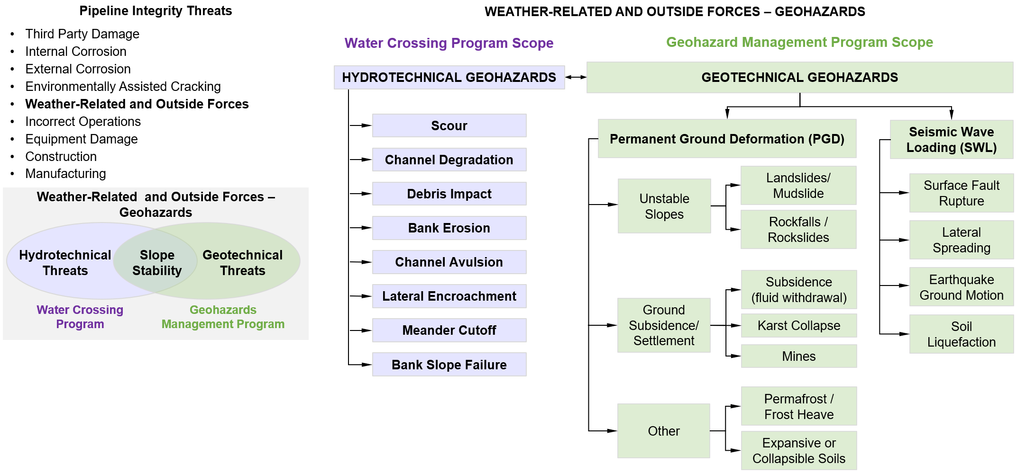

The second category of geohazards are ‘**hydrotechnical**’ hazards, where the hazards result from the action of water, and are usually associated with flowing water from streams or tidal currents. In these instances, the threat is from the action of the flowing water exposing a pipeline and then causing damage to the pipeline either from debris striking the pipe or the effects of the velocity and volume of the water itself. This includes river crossing scour and bank erosion threats.

The GMP main objective is to identify and manage the threats to pipelines from any naturally occurring or human-triggered ground movement, including seismic events. As mention above and shown in *Figure 1‑1* the GMP addresses geotechnical hazards – such as landslides, subsidence, faulting, and other similar types of hazards that result in permanent ground displacement, while hydrotechnical hazards – from the action of water, including water crossing slope stability concerns within high bank to high bank and bank erosion that may lead to slope instability, are stewarded by Global XOM WCP (see *Water Crossing Program (WCP)* [*Manual*](https://teamwork4.exxonmobil.com/sites/GlobalWCP/Shared%20Documents/WCP%20Toolkit/WCP%20%20Manuals%20and%20Guidelines/WCP%20Manual)).

Geohazards cover a wide-range of phenomena, from time-dependent (duration-based) hazards where movement or development of the hazard is measured in inches-per-year, to time-independent hazards (event-based) where the movement is measured in feet-per- second. The area of effect can range from hundreds of square miles – in the event of a large earthquake, to an area confined to a few hundred square feet – in the event of a relatively small landslide.

The terms “time-dependent” and “time-independent” are used in this document for general consistency with terminology in ASME B31.8S *[7]*, API RP 1160 *[2]*, and other pipeline integrity related references. In the context of this document, “time-dependent” (duration based) should be understood to be geohazards that develop or move slowly and typically allow for the hazard to be managed primarily through a process of monitoring and reassessment. “Time- independent” (event-based) geohazards move or develop rapidly with limited or insufficient time for intervention once the event begins.

Figure 1‑2. Examples of Typical Geotechnical Hazards

|  |  |
| --- | --- |
|  |  |
| *Landslide Collapse, North Dakota Dec 5, 2016* | |
| Monitoring Before Mitigation | After Mitigation Completion |
| *Active Landslide, Economy Yard, Canada AB* | |
|  |  |
| *Daisetta Sinkhole Sudden Collapse, May 7, 2008* | |

## Program Application

The GMP applies for the entire life span of the pipeline from conception and design to construction and operation, and until the pipeline system is decommissioned. Thus, this GMP is designed to be implemented in a way to ensure that critical information is maintained and accessible for the lifetime of a pipeline asset.

The core principles that reinforce the GMP are based on the analysis of historic events as well as on generally accepted geologic processes as per Geosyntec *[14]*, *[15]*, *[16]*, *[17]*.

**The GMP approach is based on ten key concepts**:

* The GMP is a systematic process that proactively minimizes the potential for loss of containment (LOC) events from geohazards and reduces to as low as reasonably practicable (ALARP) the overall costs associated with long-term geohazard management.
* The GMP encompasses the entire pipeline life cycle, from original routing, design, operation, to decommissioning.
* The GMP applies to all facilities operated by ExxonMobil referred in this document as ExxonMobil Corporation (XOM). This includes pipelines and associated facilities, such as terminals, pump or compressor stations. However, this document is focused on assets that are in the public domain (i.e., pipelines, service lines, in-field lines).
* The GMP focuses on those hazards that are most likely to affect assets operated by XOM. Efforts will not be put forth to address hazard types not actually encountered or in close proximity (i.e., generally within 200 feet or 60 m from a pipeline route) to assets.
* The GMP uses consistent terminology, common assessment methods, consistent & transparent response criteria (i.e., whether monitor or mitigate, which potential methods to use), consistent data storage methods.
* The GMP structure/approach is not dependent on a particular individual, consultant, or vendor. It is flexible enough to provide a consistent outcome regardless of the geohazards along a particular pipeline segment and between various geographical regions.
* Decisions on response for action (such as whether to mitigate or monitor a location) should be made by risk owners (e.g., Site/Area or Terminal Manager) based on geohazard screening or engineering assessment recommendations provided by internal or/and external geotechnical and integrity SMEs.
* A system-wide, cycled, phased identification and assessment process to identify the locations of past or ongoing geohazards threats is a cornerstone of the GMP.
* Most geohazard locations can be effectively managed through a process of regular monitoring and reassessment. If hazard investigation and characterization determine that a hazard is time-dependent, then monitoring and/or temporary/phased mitigation should generally be the first option for geohazard management, with permanent mitigation being reserved for sites:
  + *With the highest likelihood of occurrence,*
  + *With hazards that are not time-dependent, such as seismic events or*
  + *When implementation of permanent mitigation requires more time than allowed by the time-dependent geohazard before pipeline integrity is significantly impacted.*
* The geohazard inventory and assessment process should collect only site-specific information needed to make an informed decision about actions for an individual geohazard site.

GMP Documentation, Tools and Forms

The GMP Key Master Documentation is located at Global GMP Site [[*goto/globalgmp*](https://teamwork3.exxonmobil.com/sites/GlobalGMP/Shared%20Documents/Forms/AllItems.aspx)]

* The [*GMP Manual*](https://teamwork3.exxonmobil.com/sites/GlobalGMP/Shared%20Documents/GMP%20Toolkit/GMP%20Manuals%20and%20Guidelines/GMP%20Manual) is designed to provide an overview of the GMP scope, objectives, organization, and workflow including the recommended approach to measure, manage, and monitor all aspects of the GMP.
* The [*GMP Training Materials*](https://teamwork3.exxonmobil.com/sites/GlobalGMP/Shared%20Documents/GMP%20Toolkit/GMP%20Training%20Materials) are designed to train, instruct, and guide Geohazard Management Engineers (GMEs) & GMP Leads on how to implement and execute the GMP.
* The developed technical [*GMP Tools and Forms*](https://teamwork3.exxonmobil.com/sites/GlobalGMP/Shared%20Documents/GMP%20Toolkit/GMP%20Tools%20and%20Forms) are used to implement the stages of the GMP workflow and serve to drive quality and consistency and maintain sustainability within the program.
* The key external industry available GMP related references are summarized in [[*GMP References*](https://teamwork3.exxonmobil.com/sites/GlobalGMP/Shared%20Documents/GMP%20Toolkit/GMP%20References/PIP%20CVS02010.pdf)](https://teamwork4.exxonmobil.com/sites/GlobalWCP/Shared%20Documents/WCP%20Toolkit/WCP%20References).

# GMP Workflow Process

The GMP workflow (*Figure ES 1* or *Figure 2‑1*) includes seven stages of evaluation/activities as following:

* *Stage 1.* Inventory
* *Stage 2*. Screening and Prioritization.
* *Stage 3*. Data Gap Assessment and Inspection
* *Stage 4* Engineering Assessment
* *Stage 5* Risk Assessment
* *Stage 6.* Monitoring
* Stage 7. Mitigation

Figure 2‑1. Geohazard Management Program Workflow Stages and Process Steps

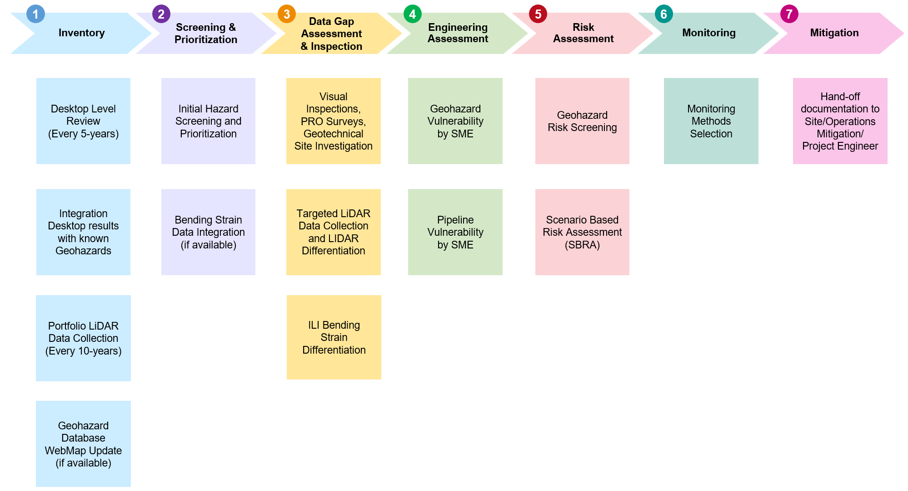

The following *Sections 2.1 – 2.7* will describe the scope and activities for each Stage of the Program.

## Stage 1 – Inventory

The inventory *Stage 1* of the GMP applies to both new projects and operating assets. This hazard identification stage is fundamental for understanding geohazard conditions that could potentially impact the integrity of pipelines. A detailed discussion of what constitute potential “geohazards” affecting pipeline integrity, and trigger mechanisms, is presented in *[Appendix B – Introduction to Geohazard Threats](https://teamwork3.exxonmobil.com/sites/GlobalGMP/Shared%20Documents/GMP%20Toolkit/GMP%20Manuals%20and%20Guidelines/GMP%20Manual/Appendix%20B%20Introduction%20to%20Geohazard%20Threats)*. The majority of geohazards affecting pipeline integrity are related to landslides. However, the GMP *Stage 1* includes all types of geohazards that could potentially affect a pipeline, including ground subsidence, sinkholes, fault raptures, expansive/collapsible soils, earthquake ground motion, soil liquefaction, lateral spreading and frost heave as described in [*Appendix B*](https://teamwork3.exxonmobil.com/sites/GlobalGMP/Shared%20Documents/GMP%20Toolkit/GMP%20Manuals%20and%20Guidelines/GMP%20Manual/Appendix%20B%20Introduction%20to%20Geohazard%20Threats)*.*

*Stage 1* of the GMP is initiated for new or acquired pipelines upon approval of the requested change by management. The GMP Technology Lead should be informed in case of any changes to pipeline testing schedules, including the addition or removal of segments from the Integrity Assessment Plan (Downstream) or Asset Integrity Management Plan (Upstream), such as when a new pipeline is commissioned or added to the portfolio via acquisitions. Significant land use changes on operating assets identified via right-of-way (ROW) aerial patrols and ROW inspections completed by the Site Monitoring team or/and Damage Prevention Group should reported to the GMP Technology Lead.

Figure 2‑2. GMP Stage 1 – Inventory

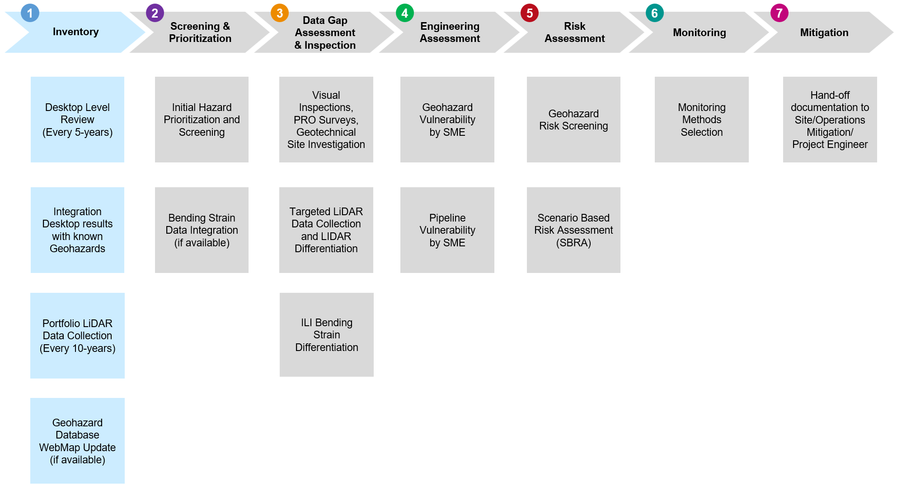

### Existing Pipelines

During operation of existing assets, the inventory hazard identification stage is typically completed through a desktop-level review of pipeline systems ROW – to preliminarily identify possible geohazard locations. Although the review is conducted at a desktop- level, it is still a detailed evaluation that serves as the basis for all subsequent identification and assessment activities. Hazard Identification desktop-level review, also known as *Level 1 Screening*, forms a baseline and should be conducted for all pipeline systems and related facilities. While the actual workload to conduct the assessment will vary by location, all systems should be assumed to have exposure to geohazards prior to the assessment. Therefore, all assets should undergo a *Level 1 Screening* review at under this GMP where Inventory development *Stage 1* is followed by *Screening and Prioritization* *Stage 2.* More discussion on *Stage 2.* scope is given in *Section 2.2.1.*

Developing a preliminary understanding of the geological and environmental conditions along the pipeline ROW is critical for identifying potentials geohazards. This includes:

* Study of the geological background, geomorphology, and geological structures of a region. The United States Geological Survey (USGS) offers an extensive database of geologic studies in the form of surveys, reports, maps, metadata and dashboards *[40]*, *[41]*, *[42]*, *[43]*, *[44]*, *[45]*, *[46]*, *[47]*.
* Review of maps and studies on existing geohazards conducted by government agencies or academic and research institutions that are publicly available such as databases of all quaternary faults, probabilistic seismic hazard maps, prior landslide mapping, etc.
* Review of hydrological data such as precipitation, streamflow, and groundwater levels and hydrography.
* Review of available stratigraphy and soils data.
* Light Detection and Ranging (LiDAR), historical mapping, and remote sensing imagery that has been collected by others and is publicly available to identify steep terrain or historical land changes.

Desktop review of publicly available sources can aid in identifying the types of geohazards that are relevant in each region. However, where localized geohazards are present, site-specific information becomes critical for understanding their effects on the pipelines. Soil surveys can be very general and inaccurate at some locations. Knowledge of the subsurface soil profile is a data gap commonly identified in desktop reviews. Furthermore, public LiDAR Digital Elevation Models (DEMs) typically have low resolution or metadata gaps that make it challenging to determine when images were acquired. High- resolution, privately acquired LiDAR DEMs are helpful to refine a desktop review and remove the inherent uncertainties of publicly available information. Therefore, it can be used to remove areas thought to be geohazards from a desktop review perspective with a high-level of confidence. Furthermore, it is helpful to have baseline LiDAR on all assets for future management of geohazards, particularly in terms of future LiDAR differentiation needs as explained in *Data Gap Assessment and Inspection* *Stage 3.*

Since geohazards are dynamic in nature, the desktop review should be re-visited at least every 5-years to ensure conditions have not changed either by time-dependent processes or event-based triggers that may have occurred since the previous desktop review. In addition, this GMP recommends collection of private LiDAR for LiDAR differentiation on all assets at least every 10-years. High-resolution LiDAR should be collected as per [*GP 85-03-02U*](https://ishareteam8.na.xom.com/sites/EMEPS/_layouts/15/DocIdRedir.aspx?ID=4MRYFQJJP6TF-679258695-1474) Airborne Remote Sensing Data Acquisition, and the results should be used to update and refine the GMP inventory.

### New Built Pipelines

All new built pipeline must comply with ExxonMobil Global Practice [*GP 59-01-04U*](https://ishareteam8.na.xom.com/sites/EMEPS/_layouts/15/DocIdRedir.aspx?ID=4MRYFQJJP6TF-679258695-1326) Onshore Pipeline Geohazards Survey and [*GP 59-01-02U*](https://ishareteam8.na.xom.com/sites/EMEPS/_layouts/15/DocIdRedir.aspx?ID=4MRYFQJJP6TF-679258695-1322) Seismic Design of Pipelines. If a pipeline is at the preliminary design phase, the potential effects of geohazards must be considered at the stage of route selection. A regional understanding of geohazards needs to be established before evaluating corridor alternatives. Geologically-complex and geohazard-prone areas – such as steep terrain, fault zones, karst or sinkhole-prone areas, old mines etc. – should be identified along the proposed routes.

Developing a Geographic Information System GIS-based platform, where LiDAR data and existing geological surveys can be superimposed with route alternatives, is a great tool for decision making at this stage. In areas of complex geologic conditions, additional remote sensing data or SME site reconnaissance may be needed to enhance the understanding of geohazard threats. Avoidance of geohazard-prone areas is the most sensible approach at this phase. If that is not feasible, then potential threats to the pipe need to be delineated along the proposed route and inventoried. The geohazard type, exact location with regards to the pipe alignment as well as extend or magnitude and activity level as per [*Appendix C – Hazard Classification*](https://teamwork3.exxonmobil.com/sites/GlobalGMP/Shared%20Documents/GMP%20Toolkit/GMP%20Manuals%20and%20Guidelines/GMP%20Manual/Appendix%20C%20Hazard%20Classification), should be included in the geohazard inventory.

Evaluation of the potential threat to the pipeline at all the locations by understanding the mechanism that each geohazard can affect pipeline integrity is required. This is done by assigning a preliminary hazard rating as per [*Appendix C*](https://teamwork3.exxonmobil.com/sites/GlobalGMP/Shared%20Documents/GMP%20Toolkit/GMP%20Manuals%20and%20Guidelines/GMP%20Manual/Appendix%20C%20Hazard%20Classification) to characterize the site’s overall activity and potential to impact the pipeline asset. At the preliminary design, the mitigation of the geohazard can be achieved through avoidance by rerouting or switching to trenchless installation.

The pipeline inventory created during the preliminary design phase is to be maintained and updated as the pipeline project moves to detailed design. This may require collection of supplemental data such as remote sensing data, site reconnaissance reports, and/or topographic surveys.

All locations of concern are re-classified based on additional information that becomes available. If the hazard rating remains high, detailed site investigations and geotechnical analyses may be required. In areas where geohazards are present, but rerouting is not an option due to constructability, land acquisition, cost, permitting, and/or other practical considerations, other alternatives such as slope stabilization, soil improvement, or drainage improvement need to be considered. If potential pipeline strain is expected due to ground movement, unsupported spanning, and seismic loading, expected peak strain level should be considered during Onshore Pipeline Design implementation per [*GP 59-01-01U*](https://ishareteam8.na.xom.com/sites/EMEPS/_layouts/15/DocIdRedir.aspx?ID=4MRYFQJJP6TF-679258695-1315) & [*GP 59-01-01M*](https://ishareteam8.na.xom.com/sites/EMEPS/_layouts/15/DocIdRedir.aspx?ID=4MRYFQJJP6TF-679258695-1909). This includes a site-specific analysis to understand loading conditions and material mechanical properties needed to maintain acceptable levels of pipeline operation and safety. Furthermore, final designs must comply with *[GP 59-01-02U](https://ishareteam8.na.xom.com/sites/EMEPS/_layouts/15/DocIdRedir.aspx?ID=4MRYFQJJP6TF-679258695-1322)* Seismic Design of Pipelines.

In areas that are adversely impacted by geohazards, the design can proactively incorporate a sophisticated monitoring system that includes both ground and pipeline instrumentation (inclinometers, accelerometers, optical fiber cables, etc.).

Knowledge of anticipated hazards, careful observation, discussion, and mitigation are essential elements of the construction process to ensure safety and successful project completion. In areas that are heavily impacted by geohazards, pipeline construction activity presents additional risks for personnel safety. Areas where known geohazards have been identified should be outlined in construction drawings and machinery access exclusion zones should be considered. Construction methods (i.e., vegetation clearing, excavations, and fill placement) as well as workspace layouts (i.e., loading/unloading areas) could act as triggers to geohazards such as landslides by altering the shape of slopes, drainage paths, or stability equilibrium and adding surcharge loads.

Pipeline construction activities also offer a great opportunity to enhance the understanding of threats in a geohazard prone area for the following reasons:

* Clearing ROW from vegetation will allow identification of ground movement signs such as tension cracks, differential settlements, sinkholes, etc.
* Surveying of the ROW can refine and improve ground elevation models created using LiDAR data, topographic maps, or other methods.
* Excavation of test pits and pipeline trenches allows evaluation of subsurface conditions and refinement of geotechnical models.

During the construction phase, the inventory is updated for known and newly identified geohazards. The locations of concern should be re-classified based on additional information as it becomes available.

Mitigation of existing geohazards is done as part of the pipeline design (e.g., stabilization of unstable slopes). Additional measures may be required where construction activities have revealed or could trigger new geohazards. If a continuous monitoring plan is part of the pipeline design, then survey benchmarks and monitoring equipment (for ground conditions or the pipeline) should be installed during this phase.

### Ground and Aerial Reconnaissance

Observations by field personnel have proven to be valuable in identifying geohazards. ROW personnel and aerial patrol crews conduct numerous inspections every year, and familiarity with the pipeline corridors allow them to identify noticeable changes. Often, these inspections are specific to other pipeline maintenance tasks or focused on third party damage or encroachment. Any potential geohazard reported by ROW personnel should be added to the inventory and must undergo the seven-stage process to manage the threat. Typical features reported by field personnel and aerial inspectors include:

* Hummocky (undulating) ground
* Rippled ground
* Cracks
* Scarps
* Presence of water and natural drainage conditions
* Changes in vegetation type, density, and habit (e.g., curved tree trunks, toppled trees)
* Scour.

Typically, conducting a ground reconnaissance is focused on two aspects:

* Visual assessment to confirm the presence of a geohazards related morphology relative to the pipeline location, and
* Determination of the potential hazard that the given geohazards may pose to the buried pipeline.

For more details refer to FIMMS [*ROW Maintenance Program*](https://ishareteam2.na.xom.com/sites/empcolib/Manuals/FIMMS%20Manual/FIMMS%20-%20ROW%20Maintenance%20Program.pdf) & [*Aerial Patrol Inspection Program*](https://ishareteam2.na.xom.com/sites/empcolib/Manuals/FIMMS%20Manual/FIMMS%20-%20Aerial%20Patrol%20Inspection%20Program.pdf)for EMPS and FIMS Equipment Integrity Guides ([*EIG-03*](https://ishareteam3.na.xom.com/sites/EMPC0849/Pipelines/2Technical%20Manuals%20and%20Reference%20Documents/EIG%2003.pdf)) & Technical Reference Manual ([*TRM-03*](https://ishareteam3.na.xom.com/sites/EMPC0849/Pipelines/2Technical%20Manuals%20and%20Reference%20Documents/TRM-03_Final.pdf)) for Pipelines for Upstream.

During the geohazard identification stage, the ground or/and aerial reconnaissance (site inspection) by Geotech SME may be required to define further response. SME aerial reconnaissance provides a real-time (current), close-up, synoptic view of the terrain along the pipeline ROW so that the current geomorphology can be viewed for evidence of ground disturbance related to landslides. It can be deployed after an intense storm to detect whether any ground movement have been triggered or after a significant seismic event to see if ground shaking has triggered ground movement. The reconnaissance can be conducted with helicopter, drone, or fixed-wing aircraft. The results can be used during *Stages 1-5* of the GMP.

### Inventory Stewardship

A Geohazard Management Program inventory (GMP Inventory) functions as a central database for storing, tracking, updating, managing, and reporting the geological and geotechnical data collected within the pipeline ROW. As such, the geohazard program inventory contains the up-to-date status of each known geohazard location in the GMP and tracks assessment progress through each GMP Stage. In addition, the geohazard inventory serves as a GIS storage database for all geological and geotechnical data collected for each pipeline asset. Common data sources include soil boring data, LiDAR, InSAR (Interferometric Synthetic Aperture Radar), DEM, topographical maps, geologic reports, and ground/aerial reconnaissance data. After completion of each program stage, the GMP inventory is updated to reflect the most current knowledge and document the obtained results.

The GMP inventory system of record is the GIS-based geodatabase. The GMP inventory is a working document that contains all the identified geohazards that could potentially impact the pipeline integrity. The inventory includes information on the type, location, and activity level of geohazards, triggering mechanisms, monitoring criteria, and additional information that could be useful in an emergency response situation. An example of information included in the inventory is shown in *Table 2‑1* below.

To maintain consistency, standard terminology is used within the GMP Inventory Database. Unique identifications (Hazard IDs) are applied to geohazard features that are tied to the geohazard and geographic location (not a pipeline or stationing). This is to facilitate tracking and discussion around a geohazard and is particularly useful in areas with multiple pipelines or numerous geohazards.

The naming convention used to create unique hazards identifiers combines a two-letter Country identifier, a three-letter identifier of the type of geohazard of concern, with additional two-letter identifier for sub-categories, and a unique three-digit number identifier as summarized in below:

Country Identifier: “US” for the United States, “CA” for Canada, “UK” for United Kingdon, “AU” for Australia, etc.

Geohazards Type:

|  |  |
| --- | --- |
| HHT: Hazard – Hydrotechnical  HLS: Hazard – Landslides  HLS_DF: Hazard – Landslides – Debris Flow  HSB_KT: Hazard – Subsidence – Karst  HSB_FW: Hazard – Subsidence – Fluid Withdrawal | HSB_UM: Hazard – Subsidence – Underground Mining  HSM_GM: Hazard – Seismic – Ground Motion  HSM_FR: Hazard – Seismic – Fault Rupture  HSM_LQ: Hazard – Seismic – Liquefaction  HSC: Hazard – Special Cases |

For example, US–HSB_KT-001 corresponds to a location in the USA where there is subsidence hazard due to karst, while CA-HLS-102 would be a location in Canada with landslide hazard, etc.

For the geohazard database management and sustainment, it is recommended to have a core team with multi-disciplinary experts responsible for data collection, processing, analysis, storage, and digitization including planning, permitting, engineering, geologists, data analysts, and GIS staff. When potential geohazards are identified, the information about new threats needs to be recorded in the GMP GIS-based database. In addition, it is recommended to log new records with a short narrative description of the identified geohazard to provide context for the above recorded information.

Table 2‑1. Minimum Geohazard Inventory Information

|  |  |
| --- | --- |
| Field entry | Description |
| Geohazard Identifier | A unique identifier of the hazard that includes location information and hazard type |
| Business Line | Business line owns pipeline or facility asset |
| Site | A site name operates pipeline or facility asset |
| County, State, Country | Geographic region |
| Latitude | The latitude for the location of the hazard |
| Longitude | The latitude for the location of the hazard |
| Status | The status of the geohazard review, e.g., screening in progress, further evaluation needed, evaluated by SME, monitoring in progress, mitigated |
| Dates | Date of screening, evaluation, monitoring, mitigations, etc. |
| Type of Geohazard | Depending on the geohazard there may be different types, e.g., hydrotechnical, interactive (combinational), landslide, debris flow, ground subsidence, seismic, etc. |
| Direction of Movement | Direction of movement such as axial, oblique, or transverse |
| Rate of Movement | Recorded or estimated rate of movement if applicable |
| Length | Estimate of length of affected area |
| Width | Estimate of width of affected area |
| Depth | Estimate of depth, i.e., shallow (0 - 3ft), moderate (3 - 10ft), deep (> 10ft), unknown |
| Relation to the Pipeline | Orientation of the geohazard or relative location with respect to the pipe; *Figure 2‑3*. |
| Last Known Movement | Information such as date and description of movement |
| Activity Status | Current state of activity of the hazard, e.g., Active, or Inactive |
| Monitoring Method | Type of monitoring used, sensor locations, frequency, etc. |
| Pipeline Operating Info | Product, Temperature, Pressure |
| Pipeline Properties | Grade, OD, WT, coating type, Specified Minimum Yield Stress (SMYS) |

Figure 2‑3. Conceptual Examples of Distance Relationships Between Geohazards and Pipeline

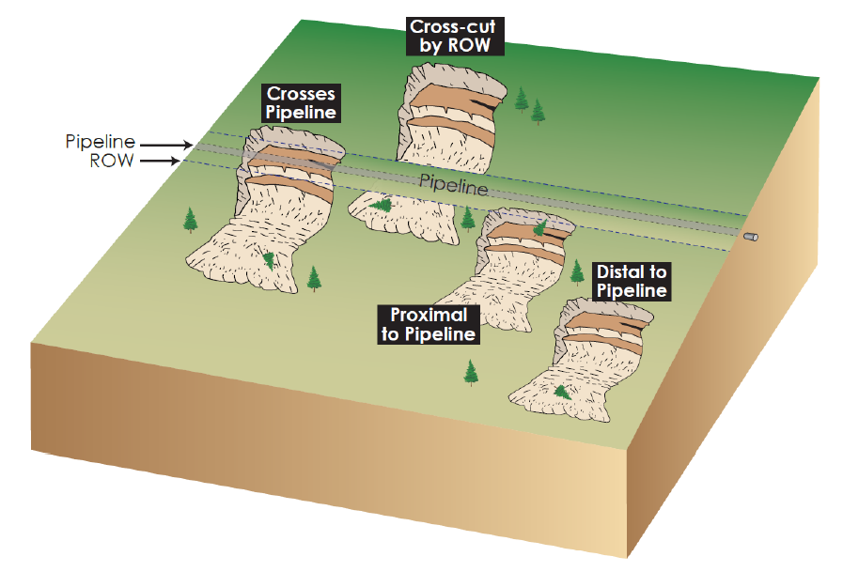

Source: Geosyntec (2019b), *[15]*.

## Stage 2 - Screening and Prioritization

### Hazard Screening and Prioritization

All pipelines and associated facilities should be screened to identify possible geohazard locations through ***desktop*** regional hazard identification study - *Level 1 Screening*, which is a desktop study intended to systematically generate an initial inventory *(Stage 1)* of possible geologic and geotechnical hazards (i.e., geohazards) along an extent of pipeline and initially characterize and prioritize the potential threat associated with each identified hazard *(Stage 2)* as shown in *Figure 2‑4*. More details are given in *[Appendix C – Hazard Classification](https://teamwork3.exxonmobil.com/sites/GlobalGMP/Shared%20Documents/GMP%20Toolkit/GMP%20Manuals%20and%20Guidelines/GMP%20Manual/Appendix%20C%20Hazard%20Classification)* and Geosyntec, *[12].* Based on the identified threat, selected hazards can be assessed through more detailed analysis, such as *Level 2 Screening* leveraging data collected via site field reconnaissance and possibly *Level 3 Screening* leveraging site-specific investigations such as soil bore data collection and lab testing as needed. The site inspection and data collection are typically conducted based on *Level 1* desktop screening results as part of GMP *Stage 3*. See *Section 2.3* for more details.

The GMP screening and prioritization *Stage 2* uses a Ranking classification system to identify which geohazards fall into the GMP scope (e.g., assessment or/and monitoring or/and mitigation). The geohazard screening stage of the GMP functions to identify and prioritize locations where (1) additional data may be necessary to complete a geohazard assessment, and (2) subsequent monitoring program needs to be established to track further changes. The GMP data integration / screening *Stage 2* can be revised when new data become available.

Figure 2‑4. GMP Stage 2 – Screening and Prioritization

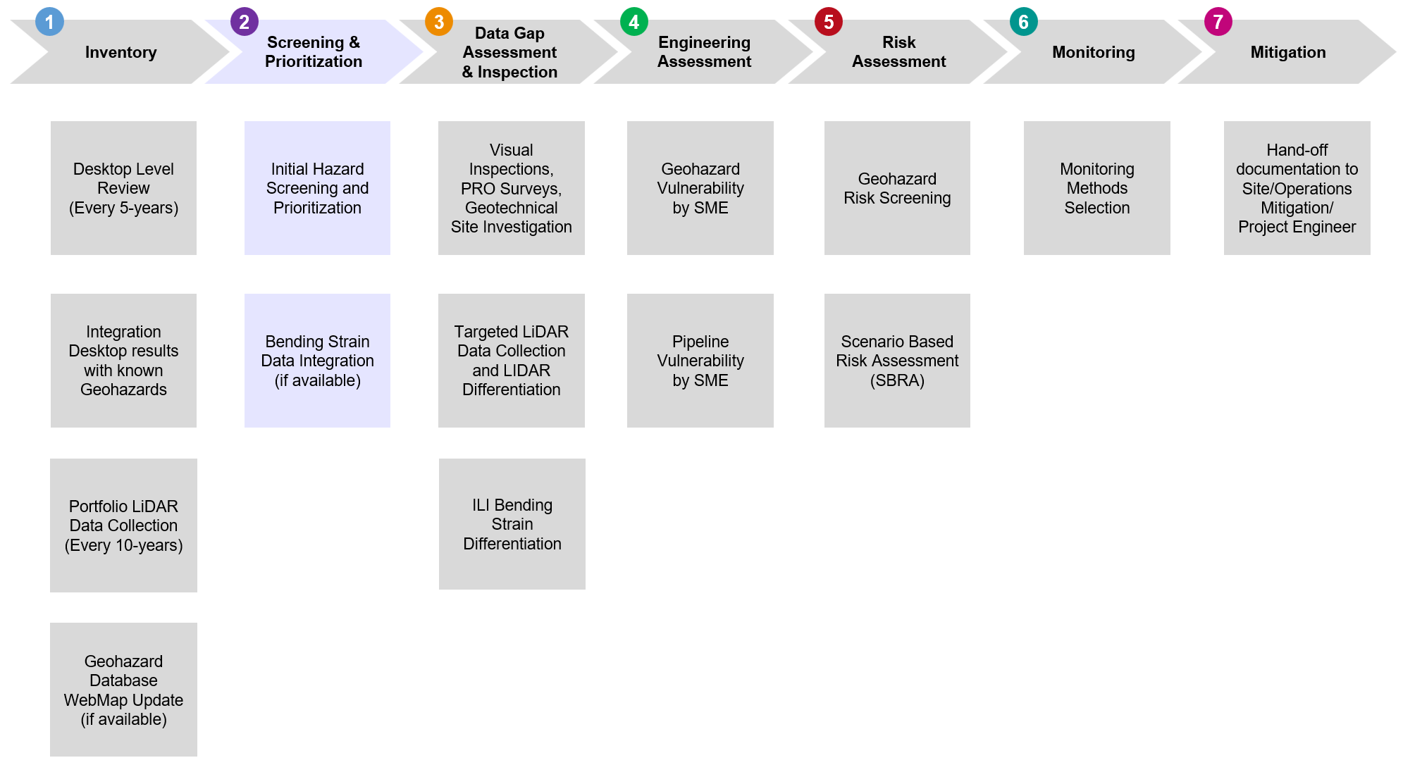

The GMP *Screening and Prioritization* *Stage 2* is focused on geotechnical hazards and is based on an index-based classification system for geomorphic concerns that uses a combination of variables for each geohazard to rank each hazard. Each variable is categorized based on its assumed likelihood of affecting a pipeline's integrity. The variables are extracted from observations retrieved from desktop examination and publicly available sources as described in [*Appendix C – Hazard Classification*](https://teamwork3.exxonmobil.com/sites/GlobalGMP/Shared%20Documents/GMP%20Toolkit/GMP%20Manuals%20and%20Guidelines/GMP%20Manual/Appendix%20C%20Hazard%20Classification).

The results of the geotechnical hazard prioritization feeds into the bending strain data integration for decision making as described in [*Appendix D – Bending Strain Data Integration*](https://teamwork3.exxonmobil.com/sites/GlobalGMP/Shared%20Documents/GMP%20Toolkit/GMP%20Manuals%20and%20Guidelines/GMP%20Manual/Appendix%20D%20Bending%20Strain%20Data%20Integration). If there is enough data available to provide a reasonable level of confidence that the hazard can be monitored, either during next ILI bending strain, next revision of *Level 1* desktop screening review, or a specific timing provided by a geohazards SME, then the hazard goes to Monitoring (*Stage 6*). However, if additional data is required, then the hazard moves into *Data Gap Assessment and Collection* (*Stage 3*).

Every time additional information becomes available, the hazard classification should be revisited to ensure the latest information is used to update the hazard classification level. For example, once additional data is received from *Stage 3*, the classification needs to be refined based on collected site data. Refined screening results to determine:

* if a detailed engineering assessment is needed (*Stage 4*)
* define the monitoring type/frequency (*Stage 6*)
* filter location out of GMP scope as non-credible threat until the next revision of *Level 1* desktop screening.

The screening and hazard classification results should be recorded in the GMP GIS-based inventory.

The results and recommendations from the screening and prioritization provide the technical basis for hazard prioritization and decision-making which can also serve as an input for the Risk Assessment (*Stage 5*) and in turn inform mitigation decisions. Hazard prioritization and decision-making is a process to translate assessment results into recommended response using a consistent approach, provide guidance for the threat ranking and for the decision- making process for geohazard management.

### Bending Strain Data Integration and Response

The bending strain data integration process was initially developed to prioritize response to high bending strain locations where no additional geohazards information was available. The process was integrated into the GMP as a procedure for decision- making on the *Screening and Prioritization* (*Stage 2*), and it is described in detail in *[Appendix D – Bending Strain Data Integration](https://teamwork3.exxonmobil.com/sites/GlobalGMP/Shared%20Documents/GMP%20Toolkit/GMP%20Manuals%20and%20Guidelines/GMP%20Manual/Appendix%20D%20Bending%20Strain%20Data%20Integration)*.

Bending strain data integration and response is only applicable to piggable lines, and it is used every time when a new bending strain or strain change assessment is completed on a pipeline. The procedure brings into the picture not only any geomorphic threats, but also any known water crossing information from the Water Crossing Program (WCP), additional pipeline threats such as corrosion and third-party damage, as well as pipeline repair and construction history.

The outcome of the bending strain data integration efforts is priority classification level for each bending strain call. The procedure has four response levels:

* **Level 1** – Highest priority level that indicates that an active credible threat to pipeline integrity exists and further field action should be taken to evaluate/remediate
* **Level 2** – Second highest priority level that indicates a credible threat to pipeline integrity is likely and detailed data integration is required. Field investigation should be considered to perform
* **Level 3** – Perform further data integration including ILI signal review and record review to understand root cause of bending strain
* **Level 4** – Lowest priority level that indicates that a credible threat to pipeline integrity is not likely and monitoring is recommended (i.e., during next ILI tool run).

Level 1 priority locations typically require an immediate response, through *Risk Assessment (Stage 5)* and/or *Mitigation* (*Stage 7*). The main objective is to minimize the risk of pipeline failure and the potentially negative impact on the surrounding properties and environment. The key decisions are whether: (1) the affected pipeline requires immediate response – such as shutdown or pressure reduction to mitigate potential consequences, (2) there are undue risks to those living in proximity – that require immediate actions to be taken to stabilize the site and minimize possible continued damage, or (3) there is a need to mitigate the pipeline. However, a Level 1 priority location can be immediately followed by *Data Gap Assessment and Collection* (*Stage 3*), which will generate data for decision making. The decision should made thought data integration discussion with Operations/Site Representatives such as Lead Pipeline Integrity Engineer (PIE), GMP Technology Lead, GMP Engineer, SMEs, Site/Project PLR Point-of-Contact (POC), Operations, Risk Owners, etc.

Priority Level 2 through 4 locations typically can afford more time for follow-up actions, which may include the geohazards inspection, a confirmatory Inertial Measurement Unit (IMU) tool run, or a monitoring IMU tool run during the next IMP assessment. Additionally, bending strain priority levels are also revised as additional information becomes available.

## Stage 3 - Data Gap Assessment and Inspection

Data gaps are generally identified during *Stage 3*, particularly during bending strain data integration, where the geohazards engineer completes a comprehensive review of all available geohazards and pipeline information to assign a priority level for decision-making. As explained in the previous section, both the geomorphic hazard classification and the bending strain priority level may require additional data collection.

Data collection for the GMP consists of geomorphic data and pipeline data. Pipeline data may include additional confirmatory bending strain analysis, signal review by ILI vendors, other ILI technology results such as deformations, pipe location survey, etc. Note that monitoring methods are also used to collect data for continual assessment of geohazard threats. For example, slope inclinometers and strain gages are commonly used as monitoring methods in *Monitoring* (*Stage 6*). However, these methods can also be used for data collection for re-assessment of geohazards.

Geomorphic data is further divided into two data types: remote sensing data and site-specific data (either publicly available or collected by the XOM). Both data types are used for geohazard screening and preliminary hazard identification. The same methods can be used in following stages of the GMP to assist with the engineering assessment and severity evaluation of an identified geohazard or for long term monitoring.

During this Stage (*Stage 3* – *Data Gap Assessment and Collection*), the GME or/and PIE reviews all existing information for a given geohazard location and determines the need of supplemental information for *Engineering Assessment* (

*Stage* 4), or for mitigation or monitoring decisions. Any data gap assessment requires alignment with Operations/Site Representative to ensure all potential information available has been considered. Supplemental data collection may be conducted for one of the following reasons:

* There remains ambiguity after the completion of the Screening Stage of GMP about whether an identified feature is in fact a geohazard or not,
* There remains ambiguity after the completion of the Screening Stage of the GMP about the threat represented by the geohazard, and thus more information is needed to determine a response, or
* To design geohazard mitigation (see *Stage 7*) where additional subsurface information is needed, such as collecting geotechnical data to design a retention wall, stabilizing slopes, or assessing the depth of a landslide for a Horizontal Directional Drill (HDD).

The key steps/components of GMP *Stage 3* are summarized in *Figure 2‑5.*

Figure 2‑5. GMP Stage 3 – Data Gap Assessment and Inspection

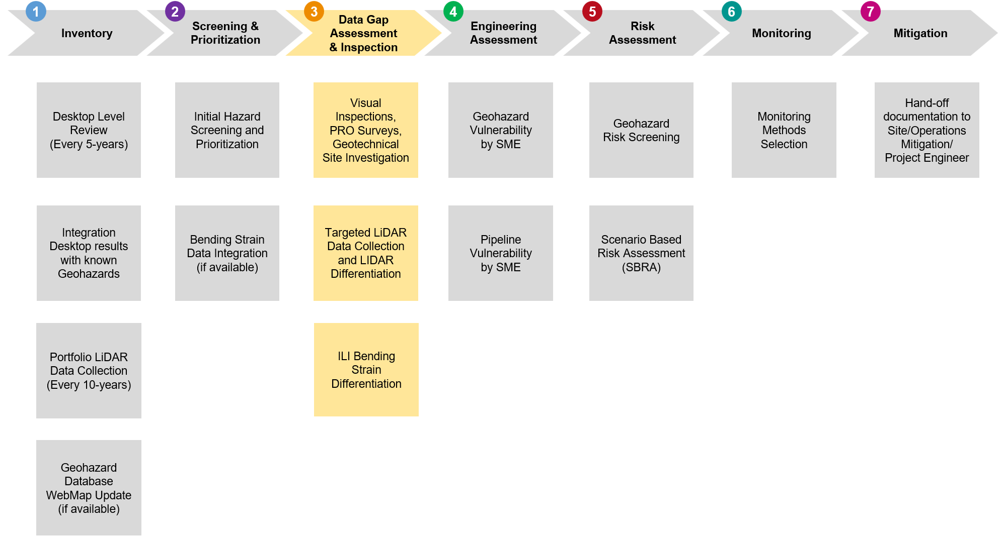

### Remote Sensing Data

The common remote sensing data sources, technologies, and methods used for geohazard identification, assessment, and monitoring are listed below. Specific details on typical remote sensing data are provided in *[Appendix G - Geohazards Monitoring Methods](https://teamwork3.exxonmobil.com/sites/GlobalGMP/Shared%20Documents/GMP%20Toolkit/GMP%20Manuals%20and%20Guidelines/GMP%20Manual/Appendix%20G%20Geohazards%20Monitoring%20Methods)*. Advantage and disadvantages of each technology are discussed, and the following methods are discussed:

* Topographic maps and DEM data
* Regional and large-scale geologic maps and reports
* Aerial photography
* Light Detection and Ranging (LiDAR)
* Interferometric Synthetic Aperture Radar (InSAR).

LiDAR technology has gained popularity among pipeline operators for managing Geohazards and it has been deemed critical in conjunction with a GIS database for a pipeline GMP by INGAA, *[21]* and API RP 1187, *[4]*. *Figure 2‑6* illustrates the output of a desktop geomorphic assessment based on LiDAR data to identify and map landslides and possible landslide locations. While the landslides are clearly delineated in the LiDAR slope map (top), they are not visible in the aerial imagery (bottom) because of the dense tree cover.

LiDAR can support monitoring a variety of geohazard cases such as landslides, subsidence, depth of cover, third party activity, encroachment monitoring, and erosion. Any new LiDAR should be collected as per technical specification in [*GP 85-03-02U*](https://ishareteam8.na.xom.com/sites/EMEPS/_layouts/15/DocIdRedir.aspx?ID=4MRYFQJJP6TF-679258695-1474) *Airborne Remote Sensing Data Acquisition*.

LiDAR change detection is performed to identify, evaluate, and monitor the activity of geohazards. LiDAR change detection analysis allows for detection, analysis, and monitoring of geohazards over large areas by comparing two or more overlapping LiDAR-generated DEMs collected at different times. The process consists of analyzing a change detection raster image (i.e., a matrix of change in elevation data) to identify areas of apparent real change of the ground surface (vs. apparent change that is the result of measurement noise), classification of those areas of change, and documentation, as described below.

Figure 2‑6. Example of LiDAR Geohazard Assessment

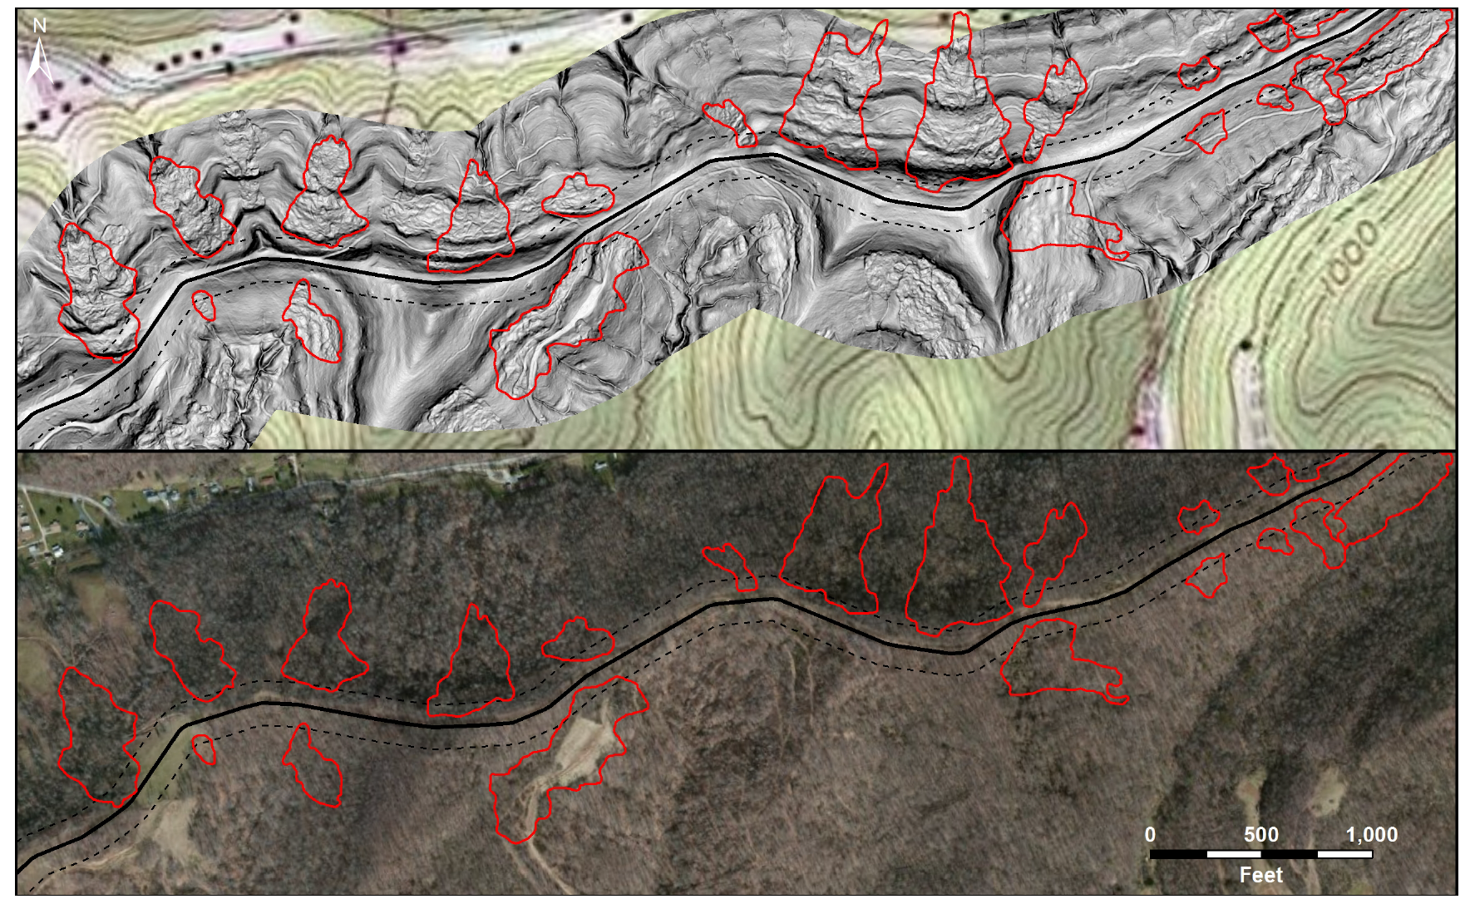

Source: INGAA (2020), *[20]*.

(LiDAR data (gray shaded slope map overlain on USGS topo map in top figure) and aerial imagery (bottom figure). Landslide mapping (red outlines) along a 200-foot (60 m) wide corridor (black dashed line) centered on a pipeline (black line).)

The oldest DEM (i.e., first collected) is referred to as the “baseline” DEM. The most recent DEM is referred to as the “current” DEM. When there are three or more DEMs available, the DEM collected immediately prior to the current DEM is referred to as the “prior” DEM. A change detection raster is the resultant raster produced by subtracting an older DEM (either the baseline or prior) from the current DEM. When three or more DEMs are available, the following guidelines should generally be followed:

* The “current versus prior” raster should be the primary product for review and analysis
* The “current versus baseline” raster should generally be reserved for reference in situations where ground surface change identification or classification based on the “current versus prior” raster is unclear. The “current versus baseline” raster may be used where it is believed, or known, that slow and persistent ground creep may be occurring that is below the threshold of reliable short-term change detection.

This procedure is performed by a geohazard SME with GIS expertise. The Geohazard SME can be an internal XOM employee or a designated external third-party consultant, as appropriate.

### Site Specific Data

The common site-specific data that may be used for geohazard assessment include Ground and Aerial Reconnaissance, Geotechnical and Geophysical methods.

#### Ground Reconnaissance

Ground reconnaissance by geohazards SME, also known as *Level 2 Field Investigation*, is detailed and nonintrusive. In addition, site-specific geomorphic and geologic mapping by trained and experienced geotechnical professionals can be utilized to identify the lateral limits of the ground movement relative to the pipeline and estimate the magnitude and rate of movement. This may include the following information:

* Depth of Cover (DOC) and location of the pipeline being assessed (if relevant and not previously available)
* The size and magnitude of surficial features associated with the geohazard, such as the height of scarps and ground cracks
* Features that might indicate age of most recent movement. Geohazard features that are sharp, well-defined, and with exposed fresh soil generally indicate more recent movement. Conversely, those that are rounded, subdued, and without fresh soil exposed generally indicate older movement (see *Figure 2‑7*).
* Features that could provide information about the geohazard’s rate of movement, such as leaning or knocked-over trees and displaced anthropogenic features (e.g., roads and fences)
* An estimate whether the pipeline might have been engaged by ground movement or whether the pipe is deep and possibly below ground movement
* For smaller landslides, an estimate of the thickness of the landslide (plus or minus a few feet) and estimate of whether the landslide slip surface is above or below the pipeline(s)
* The soil and/or rock types exposed at the surface of the geohazard, and geologic structures exposed at the surface (such as joints and bedding), as applicable.

During a ground reconnaissance, it is recommended that the limits of the geohazard-related deformation and other relevant external features (e.g., cracks, scarps, seeps, etc.) are marked or outlined (spray paint, flags, stakes etc.) and captured or mapped using a handheld GPS unit or detailed topographic survey.

Data collected during ground and aerial reconnaissance that may indicate potential ground movement need to be recorded in the GMP GIS-based inventory. Additional details about Geohazards Field Investigations are provided in *[Appendix E – Level 2 Geohazards Investigations](https://teamwork3.exxonmobil.com/sites/GlobalGMP/Shared%20Documents/GMP%20Toolkit/GMP%20Manuals%20and%20Guidelines/GMP%20Manual/Appendix%20E%20Level%202%20Geohazards%20Investigations)*.

Figure 2‑7. Comparing Inactive vs. Active Geohazards

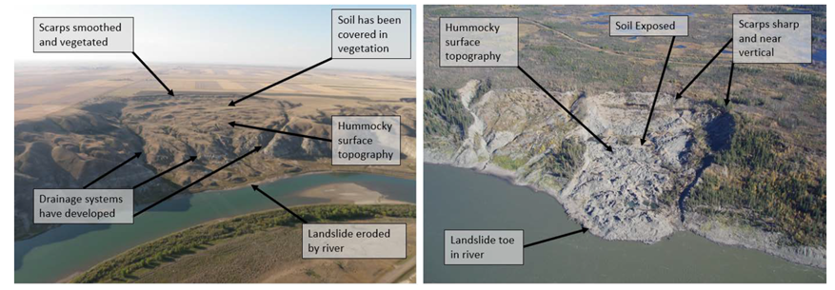

Source: Geosyntec (2019b), *[15]*.

Geohazards: Inactive (Left) is the North Saskatchewan River in Saskatchewan; Active (right) is the Mackenzie River, Northwest Territories.

#### Geotechnical Methods

Geotechnical methods include common non-intrusive inspections (*Level 2*) or intrusive site investigations (*Level 3*) that entail soil drilling and classification as outlines in [*Appendix E – Level 2 Geohazards Investigations*](https://teamwork3.exxonmobil.com/sites/GlobalGMP/Shared%20Documents/GMP%20Toolkit/GMP%20Manuals%20and%20Guidelines/GMP%20Manual/Appendix%20E%20Level%202%20Geohazards%20Investigations). Less common data collection methods include geophysical and seismic studies. Geotechnical data sources, technologies, and methods used for geohazard identification, assessment, and monitoring include the following:

* Site-Specific Geotechnical boreholes
* Survey Markers/Monuments (Surface and Underground)
* Slope Inclinometers (SI)
* Shape Arrays (SA) and Shape Acceleration Arrays (SAA)
* Extensometers
* Piezometers
* Seismic Monitors and Accelerometers.

The subsurface geologic and geotechnical conditions can be investigated with geotechnical boreholes to document and evaluate the subsurface material properties and geometry of landslides. Additionally, samples of soil and rock can be collected from the boreholes for laboratory testing of material and geotechnical properties. The boreholes can also be used to install instrumentation, including slope inclinometers and piezometers. Geotechnical soil boreholes are typically used for the detail intrusive assessment (*Level 3*).

#### Geophysical Methods

Various geophysical methods/techniques (e.g., ground-penetrating radar (GPR), electromagnetic induction (EMI), seismic refraction, seismic reflection, microgravity) can be used, with favorable conditions, to image the subsurface structure, stratigraphy, and geometry of geohazard. This information supports the geohazard assessment and development of mitigation alternatives. Geophysical data can fill-in data gaps between geotechnical boreholes. Depending on the geophysical technique, a landslide slip surface can be imaged to provide details of landslide geometry. Note that interpretations from geophysical data might be uncertain and inconclusive.

## Stage 4 – Engineering Assessment

The engineering assessment stage is a detailed engineering study of the geohazard and pipeline vulnerabilities to evaluate the severity of the geohazard and corresponding impact on the affected pipeline (i.e., pipe response analysis). The objective of the engineering assessment is to determine the likelihood (Probability of Failure (POF)) that an identified geohazards threat may impact pipeline integrity and cause loss of containment. The POF is then used with an estimated consequence to determine the risk level of such loss of containment in *Risk Assessment* (*Stage 5*).

Figure 2‑8. GMP Stage 4 – Engineering Assessment

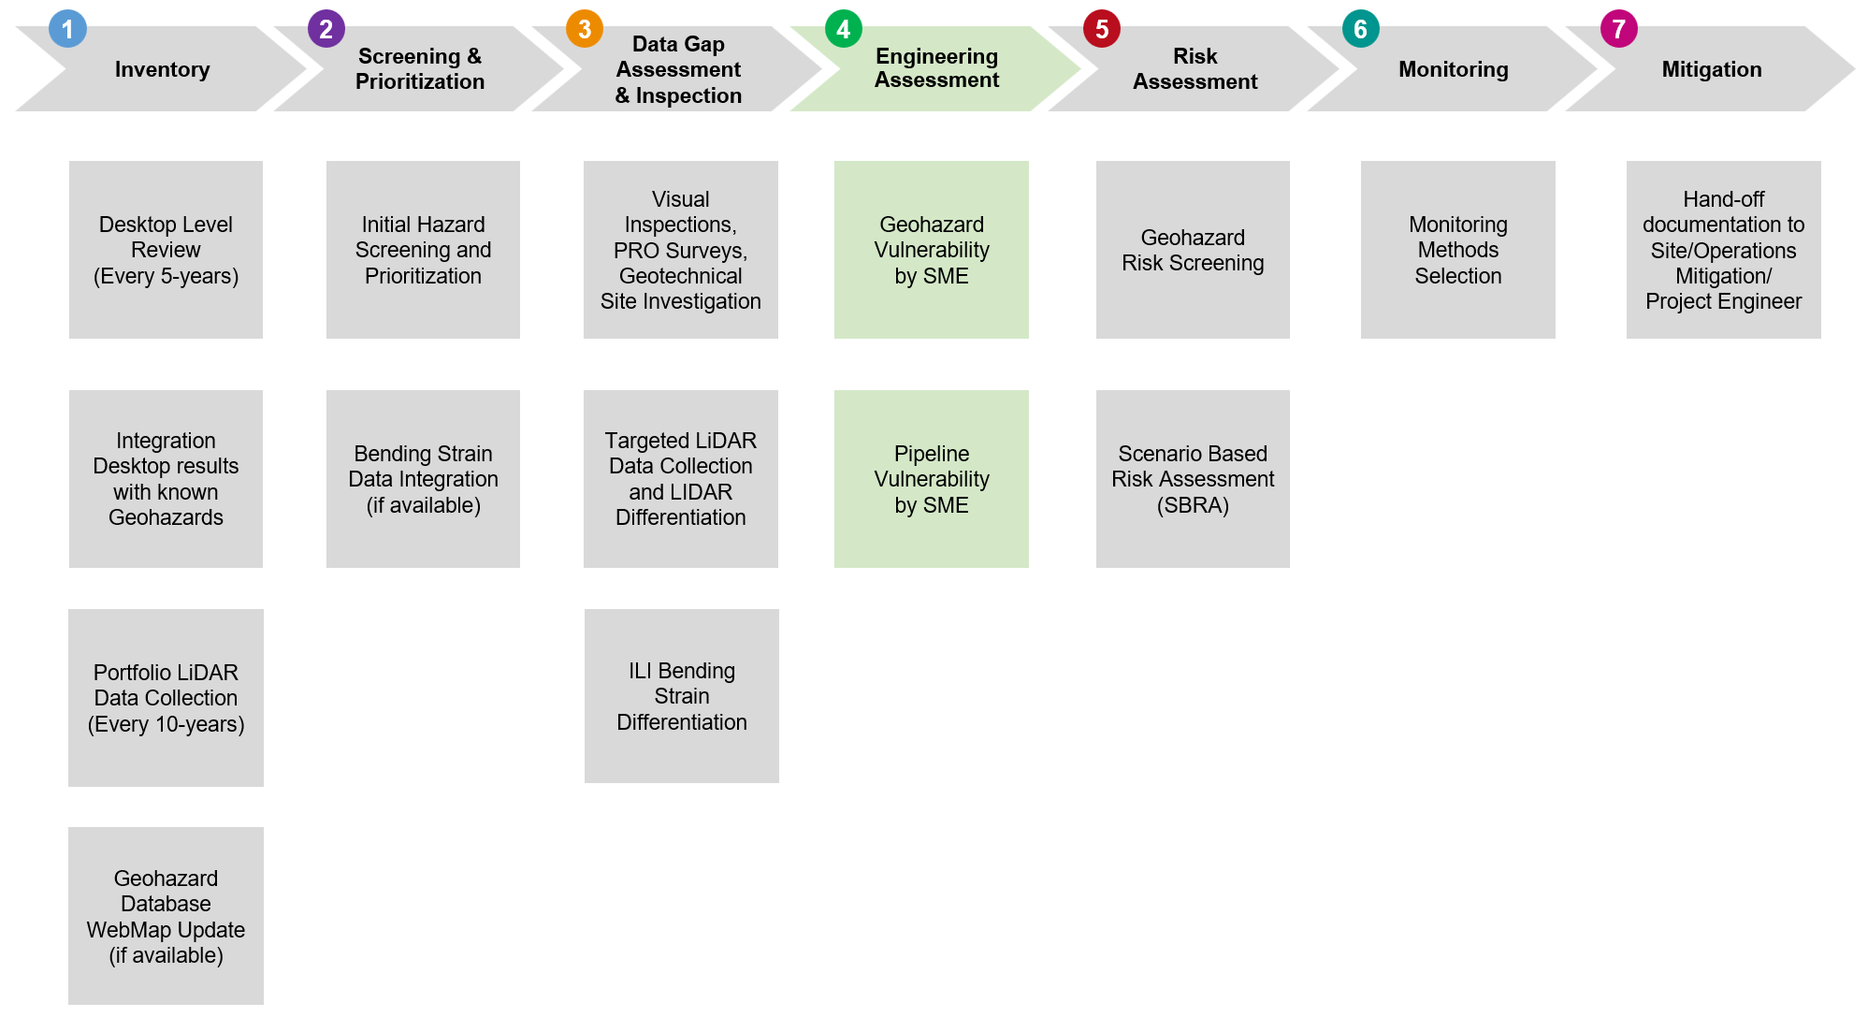

Methods to assess the susceptibility or threat posed by geohazards fall into two general categories: qualitative and quantitative.

The **qualitative** methods can be separated into two subcategories:

* Evolved from field and aerial photographic investigations based largely on experience/judgement
* Determined based upon comparison of index factor or weighted parameters.

The **quantitative** methods can be separated into two subcategories:

* Statistical methods
* Deterministic or probabilistic geotechnical models to evaluate susceptibility of hazards.

All engineering assessments as part of this GMP are completed by geotechnical and pipeline SMEs. Engineering assessment results are integrated by the GME, and results and recommendations should be aligned with Operations/Site Representative teams.

***Strain-based pipeline Fitness-for-Service (FFS) assessments should not be attempted without oversight from EMTech Materials Integrity Group.*** See *Section 2.4.2.2* for further details.

### Geotechnical Vulnerability Models

#### Overview

The deterministic analysis method refers to standard engineering slope-stability analyses carried out for specific sites. Physical properties of materials are quantified and serve as input in specific mathematical models, and Factor of Safety (FOS) is calculated. More details about FOS and slope stability analysis are given in the [*Slope Stability Assessment Manual*](https://teamwork4.exxonmobil.com/sites/GlobalWCP/Shared%20Documents/WCP%20Toolkit/WCP%20%20Manuals%20and%20Guidelines/WCP%20Technical%20User%20Guide/Appendix%20Slope%20Stability%20Assessment%20Manual), developed by WCP and incorporated by reference into GMP ([*Appendix F*](https://teamwork3.exxonmobil.com/sites/GlobalGMP/Shared%20Documents/GMP%20Toolkit/GMP%20Manuals%20and%20Guidelines/GMP%20Manual/Appendix%20F%20Slope%20Stability%20Assessment%20Manual)). Slope stability analysis, also referred to as FOS analysis, is conducted by a geotechnical SME.

The most common method used for slope stability analysis is the limit equilibrium method. Translational or rotational movement is considered on an assumed or known potential slip surface. The equilibrium of a soil mass tending to slide down is investigated under the influence of gravity. The sliding soil mass is cut into slices and then static equilibrium conditions and assumptions are applied. Two-dimensional (2-D) sections are analyzed, and plane strain conditions are assumed. These methods assume that the shear strengths of the materials along the potential failure surface are governed by linear (Mohr-Coulomb) or nonlinear relationships between shear strength and the normal stress on the failure surface.

A slope failure occurs when the embankment (slope) is no longer in mechanical equilibrium because forces that are driving movement exceed the forces that serve to resist movement. The driving forces are the weight of the upslope soils and water (and potentially structures or live loads). Resisting forces are the shear strength of the soil along the slip surface and any weight and water forces on the lower portion of the slope. The driving and resisting forces of slope equilibrium are shown on *Figure 2‑9*.

Figure 2‑9. Driving and Resisting Forces of Slope Equilibrium

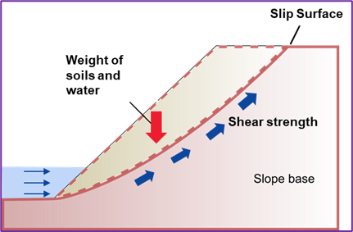

The method detailed above is very approximate and applies to movement in one direction and for straight pipe only. Numerical modelling techniques (e.g., Finite Element Analysis FEA) can provide an approximate solution to problems which otherwise cannot be solved by conventional methods such as the FOS discussed in the previous paragraph, e.g., complex geometry, material anisotropy, non-linear behavior, in situ stresses. Numerical methods used for slope stability analysis can be divided into three main groups: continuum, discrete element, and hybrid modelling. For more details regarding slope stability analysis, see [*Appendix F - Slope Stability Assessment Manual*](https://teamwork3.exxonmobil.com/sites/GlobalGMP/Shared%20Documents/GMP%20Toolkit/GMP%20Manuals%20and%20Guidelines/GMP%20Manual/Appendix%20F%20Slope%20Stability%20Assessment%20Manual).

Probabilistic geotechnical models refer to models that use standard geotechnical analyses that are coupled with a probabilistic evaluation, usually on a GIS platform, to estimate factor-of-safety or a similar index of performance over a regional area. Most geotechnical models adapted to a GIS employ some form of probabilistic input based upon assumed or known variations in soil or rock strengths, water levels and other subsurface or topographic conditions in the calculation of FOS or in a comparison of FOS values with a distribution of known hazard to estimate probability of failure. The use of probabilistic models usually employs the assumption that FOS values are normally or lognormally distributed. This allows the estimation of the standard deviation and the coefficient of variation of FOS or the individual variables that go into the FOS calculation. SME judgement is required to make these assignments on a site-specific basis.

There are various types of technical assessments that can aid the evaluation of different geohazards severity.

#### Geological Study or Survey

A geological survey is the systematic investigation of the underground geology for the purpose of creating a geological map or model. Geological surveying employs techniques such as traditional walk-over surveys, studying outcrops and landforms, and intrusive methods such as hand manual-driven (auger) and machine-driven boreholes. Other methods include the use of geophysical techniques and remote sensing methods, such as aerial photography and satellite imagery. A geological survey map typically superimposes the surveyed extent and boundaries of geological units on a topographic map, together with information at points (such as measurements of orientation of bedding planes) and lines (such as the intersection of faults with the land surface). A geological study or survey drafted by experienced geologists includes a detailed description of the geological formations and a qualitative identification of the potential geohazards.

#### Geotechnical Investigation

A geotechnical investigation aims to identify the soil profile (e.g., thickness of the soil layers, stratigraphy, and water table level) and to determine the geotechnical properties of the various geological formations. It involves primarily in-situ and laboratory tests, and secondarily geophysical testing (cross-hole or down-hole tests)

#### Tectonic or Seismicity Study

A geotechnical investigation aims to identify the soil profile (e.g., thickness of the soil layers, stratigraphy, and water table level) and to determine the geotechnical properties of the various geological formations. It involves primarily in-situ and laboratory tests, and secondarily geophysical testing (cross-hole or down-hole tests).

#### Seismological Study

A seismological study involves deterministic and/or probabilistic estimation of the reference Peak Ground Acceleration (PGA) at the rock outcrop calculated for various return periods (or equivalently for various probabilities of exceedance) depending on the pipeline limit under consideration.

### Pipeline Vulnerability Assessment

#### Overview

Pipeline vulnerability is the conditional probability that a geohazard threat event will lead to a pipeline damage or rupture event. It can be equal to one (1) when there is total failure or a fraction of the expected damage of the pipe (dents, permanent deformations, or scratches), and equal to zero (0) when the pipe is not affected by the hazard.

A pipe can be affected by ground movements in different ways. They may impose stress on the pipe by bending, tension, and compression, torsion, shearing, buckling, and necking. The type of loading and the support points, or types of support, depend on the geometry of the pipe in relation to the hazard.

The vulnerability of a pipeline to the effects of a geohazard is dependent on several factors:

* The location, type, and nature of the geohazard,
* The extent of the hazard relative to the pipeline and its orientation,
* The pipeline’s exposure to the hazard,
* The likelihood of pipeline damage or rupture due to the geohazard activity,
* The type, age, material, design parameters, and construction methods and practices of the pipeline, and
* The operational processes and maintenance procedures of the pipeline.

To define the pipeline vulnerability, a pipe response analysis needs to be conducted. The general background on pipe response analysis, including key terms and concepts are described below.

#### Stress-Based vs. Strain-Based Design

Most pipelines in operation today were designed with the principle of pressure containment in mind. That means limiting hoop stress to a percentage of the pipe’s strength as SMYS. This practice is often referred to as *stress-based* design using stress-based criteria such as Allowable Stress Design (ASD).

Pipelines, unlike pressure vessels, are subjected to loads from their environment that can cause longitudinal deformations during their life cycle. The magnitude of these loads can be unknown and, in some cases, uncontrolled, causing the pipe to deform beyond the elastic region. *Strain-based* design (SBD) refers to a pipeline design approach with the goal to maintain the pipeline serviceability and integrity under large longitudinal strains (typically larger than 0.5% longitudinal strain). The principles of strain-based design do not replace the stress-based approach but can be complimentary applied to the maintenance of pipelines in areas of large ground deformation.

Commonly used FFS assessment procedures, such as those in the British Standard BS 7910 *[9]* and API RP 579 *[3]*, were developed principally for stress-based assessment (i.e., when the nominal longitudinal strain is less than 0.2% in the context of pipeline integrity assessment). Integrity concerns arising from geohazards (landslides) typically involve strains greater than 0.2%. Therefore, using strain-based assessment (SBA) is more appropriate than using stress-based assessment when addressing geohazards, especially landslides. However, strain-based design is uncommon, particularly in the United States, given that it requires a special permit under PHMSA rules. Most vintage pipelines were designed based on stress, so stress-based assessments are often used as a first check before performing strain-based assessments. ***Strain-based pipeline FFS assessments should not be attempted without oversight from EMTech Materials Integrity Group.***

In general, SBA involves determining the pipeline strain demand relative to its strain capacity. However, accurately determining strain capacity requires extensive data inputs, which are often nearly impossible to obtain, especially for vintage pipelines. Therefore, the bending strain response criteria in [*Appendix D*](Appendix%20D%20–%20Bending%20Strain%20Data%20Integration) are primarily based on strain magnitudes that correspond to stress limits defined by code (i.e., 0.2% strain). Nonetheless, the response criteria also reference Compressive Strain Capacity (CSC) due to its relatively straightforward estimation method.

#### Estimating the Level of Stress or Strain Demand

##### Permanent Ground Deformation Loading

Soil-pipe interactions when large ground movements occur are an important consideration in pipeline design, route selection, guide monitoring, and reduction of risk of damage or failure. Pipe-soil interaction for geohazard issues can be very complex because they involve large deformations, contact definitions, material nonlinearity, and strain-dependent behavior. The finite element method provides a rigorous solution to complex problems where analytical solutions cannot be easily obtained. Two types of finite element models are commonly employed to simulate pipe-soil interactions: soil spring and soil continuum models.

##### Soil Spring Models

Engineering practice has often simplified the complex reality of soil structure interaction down to an equivalent set of springs. Soil spring-pipe models are based on a representation of soil as a set of discrete springs and the pipe as specialized beam elements. These models assume that it is possible to decouple the interaction between soil and pipe acting in different directions.

The deformation of the soil mass is modelled by the deformation of three springs (see *Figure 2‑10*) with the equivalent stiffness in the axial longitudinal, transverse horizontal, and transverse vertical directions, as described by American Society of Civil Engineers (ASCE) *[5]*, and O’Rourke and Liu *[23]*.

Figure 2‑10. Idealized Representation of Soil with Discrete Springs

Source: ASCE (1984), *[5]*.

ASCE model adapts a bi-linear relationship. Instead of shear stress and shear strain, ASCE model describes the pipe-soil interaction through the maximum soil force applied per unit length of the pipe and the critical relative displacement between the pipe and the soil when the maximum soil force is just reached. The soil forces and the critical relative displacements are provided in three directions.

The springs impart discrete reaction loads on the pipeline to represent the response of the soil continuum. The reaction loads are distributed along the longitudinal and circumferential pipeline axes. The soil spring formulations assume independent load-displacement behavior. This means that the springs do not account for pipeline/soil contact mechanisms (e.g., shear load transfer), and they lack physical significance with realistic, continuum soil behavior (e.g., load-dependent soil response).

For more details regarding soil spring calculation see [*Appendix F – Slope Stability Assessment Manual*](https://teamwork3.exxonmobil.com/sites/GlobalGMP/Shared%20Documents/GMP%20Toolkit/GMP%20Manuals%20and%20Guidelines/GMP%20Manual/Appendix%20F%20Slope%20Stability%20Assessment%20Manual).

##### Soil Continuum Models

The continuum models resolve the coupled interactions between soil and pipe more accurately and therefore allow more realistic representations of geohazards. However, soil continuum models can be quite demanding in term of computational resources and time because of the complex interactions between the modelling aspects involved and the challenges related to numerical simulations.

##### Seismic Wave Propagation Loading

Transient ground strains are caused due to either wave propagation effects or variable subsurface effects. Wave propagation effects are always present during earthquakes. The wave propagation hazard for a particular site is characterized by the peak ground acceleration (PGA) and peak ground velocity (PGV), as well as the appropriate propagation velocity and wavelength. Variable subsurface effects only occur when there are significant differences in the soil profile for two “nearby” sites, such as at the edge of a valley. That is, variable subsurface effects do not occur if the soil profiles are the same along a particular pipeline route.

There are two types of seismic waves: body waves and surface waves. The body waves propagate through earth, while the surface waves travel along the ground surface. Body waves are generated by seismic faulting while the surface waves are generated by the reflection and refraction of body waves at the ground surface. Since onshore pipelines are typically buried 4 - 10 feet (1.2 - 3 m) below the ground surface, both body and surface waves are of interest.

For the analysis and design of buried pipelines, the effects of seismic wave propagation are typically characterized by the induced ground strain and curvature. Analytical relationships have been developed to correlate the PGV of the excitation to the peak ground strain and compare with recorded pipe strains.

Damage to buried pipelines is often concentrated in areas with variable subsurface conditions (i.e., soil properties that are not uniform in the horizontal direction). Local differences in site response or site amplification are known to cause additional ground strains.

Deterministic analytical models should be used when material properties, failure modes (mechanisms and geometries), and forces are known with reasonable accuracy. FOS changes may be used to evaluate the significance of parameters or conditions. Probabilistic analyses should be used when the uncertainty in parameters may govern the results of the analysis. The probabilistic analyses quantify the likelihood of failure from geological evidence and uncertainties in input parameters and the analytical model.

All engineering assessments as part of this GMP are completed by geotechnical and pipeline SMEs. Engineering assessment results are integrated by the GME, and results and recommendations are aligned with Field Operations teams.

## Stage 5 - Risk Assessment

The Risk Assessment *Stage 5* (*see Figure 2‑11*) aligns with Global Manufacturing OIMS Practice GMOP 2.1 and consistent with XOM Risk Assessment and Management ([*TMEE-211*](https://ishareteam5.na.xom.com/sites/TKMENG061/Public%20Library/Risk%20Assessment%20and%20Management%20Guide.pdf)) and Risk Matrix Application ([*TMEE-330*](https://ishareteam5.na.xom.com/sites/TKMENG061/Public%20Library/Risk%20Matrix%20Application%20Guide.pdf)) Guides. EMGP Risk Assessment and Management Manual ([*RAM*](https://ishareteam2.na.xom.com/sites/GP-OIMS/GPOIMSDocs/02%20Identifying,%20Assessing,%20Mitigating%20and%20Accepting%20Risk/1%20System%20Documents/RAM%20Manual/EMGP_RAM_Manual_-_Rev%20(3).pdf)) provides a process for describing and quantifying risk related to a hazardous process or event, and includes the following general steps:

* Identification of the hazard and the different scenarios that may be applicable
* Estimation of consequence of failure of the pipeline/facility
* Evaluation of the frequency of pipeline failure due to the hazard occurrence as applicable
* Review of risk reducing alternatives and mitigation options.

Figure 2‑11. GMP Stage 5 – Risk Assessment

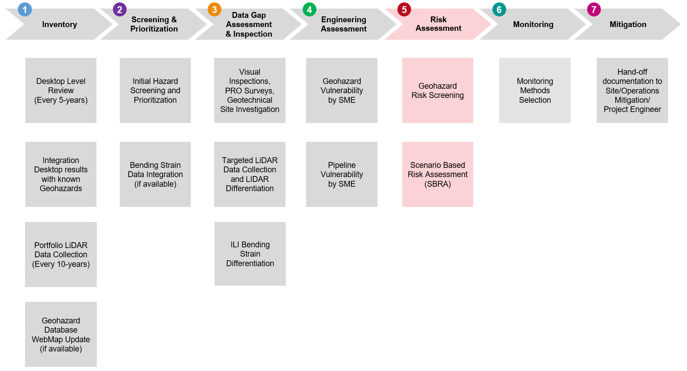

The methods to assess risk are classified as qualitative, semi-quantitative, and quantitative. Qualitative methods tend to be subjective and depend heavily on SME input and are based on observations or experience from similar conditions. Quantitative methods on the other hand are more robust but require extensive analysis of the parameters involved. Semi-quantitative are less subjective than qualitative methods and usually involve weighting factors or a penalty system calibrated at a regional scale.

Each method has its pros and cons and before selecting a method for risk assessment the following parameters need to be considered:

* The nature of the geohazard and its effects (i.e., episodic, recurrent, cyclic etc.)
* The data that is available or can be collected for assessing the geohazard (i.e., monitoring data may be available for a short period of time or the understanding of the geohazard threat may be incomplete)
* The engineering state of practice for analyzing the geohazard and the pipeline response
* The uncertainties involved.

Estimating the Probability of pipeline Failure (POF) because of a geohazard event is generally based on historical information or experience and typically used to characterize cascading or follow-on events in a hazard scenario. In some cases, the failure mechanism can be well captured in analytical or numerical models (*[19]*, *[36]*, *[37]*, *[38]*, *[48]*). However, assigning a frequency of failure (FOF) to a geohazards event to characterize the initiating event in a scenario requires either qualitative input based on SME experience or requires statistical analysis of the parameters involved in the model.

The recommendations on risk assessment strategy/schedule for identified geohazards locations should be aligned with Operations/Site Representatives and Safety, Security, Health, and Environment (SSHE) group based on input from the GMP and Geotechnical SMEs. Risk evaluations should be conducted by a certified risk facilitator (provided by SSHE) per GMOP 2.1 guidelines to identify risk category and to establish recommended mitigative measures.

Risk evaluations for pipeline geohazards management are performed per EMGP RAM ([*RAM*](https://ishareteam2.na.xom.com/sites/GP-OIMS/GPOIMSDocs/02%20Identifying,%20Assessing,%20Mitigating%20and%20Accepting%20Risk/1%20System%20Documents/RAM%20Manual/EMGP_RAM_Manual_-_Rev%20(3).pdf)) are completed by conducting risk screening conducting risk screening (initial step) or/and performing a Scenario-Based Risk Assessment (SBRA) as required. The determination of risk (the process of combining the results of Consequence and Frequency analysis into a single descriptor of risk) provides a position on the ExxonMobil Corporate Risk Matrix (see Risk Matrix Application ([*TMEE-330*](https://ishareteam5.na.xom.com/sites/TKMENG061/Public%20Library/Risk%20Matrix%20Application%20Guide.pdf)) Guide), which are then used to evaluate the need or prioritization for mitigation.

Once enough information has been collected in the stepped assessment process to characterize a geohazard, the decision-making process to determine a response include three basic options:

* Accept condition (no further action)
* Implement Mitigation
* Implement Monitoring and Operational Action Plan (including Emergency Response Plans (ERP)).

Time-dependent or duration-based geohazards develop slowly and typically allow for the hazard to be managed primarily through a process of monitoring and reassessment. Time-independent or event-based geohazards develop rapidly with limited or insufficient time for intervention once the event begins.

The risk assessment methodology for slope stability evaluation (i.e., landslides) and estimation annual POF is explained in [*Appendix F - Slope Stability Assessment Manual*](https://teamwork3.exxonmobil.com/sites/GlobalGMP/Shared%20Documents/GMP%20Toolkit/GMP%20Manuals%20and%20Guidelines/GMP%20Manual/Appendix%20F%20Slope%20Stability%20Assessment%20Manual), leveraged from the Water Crossing Program. The relationships between FOS and annual POF are based on actual engineering estimations and developed through quantified expert judgment. SME engagement/input is required to estimate POF for other geohazard threats (i.e., beyond slope stability/landslide evaluation).

## Stage 6 - Monitoring

The objective of the Monitoring (*Stage 6*) is to define the inspection type, interval for identified geohazard subjected areas, or provide potential consequence reduction during potential geohazard failure events (*Figure 2‑12*).

Figure 2‑12. GMP Stage 6 – Monitoring

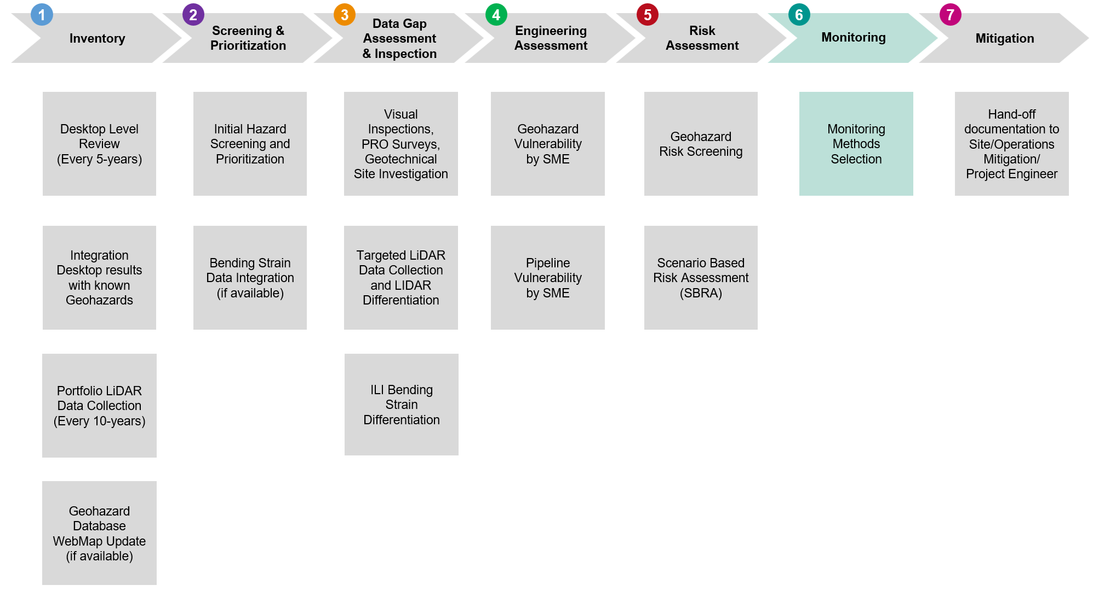

The scope and frequency for monitoring of geohazards should be determined on a case-by- case basis after consultation with Geotechnical SMEs, pipeline integrity engineers, and pipeline operations.

The general process of selecting monitoring is as follows:

* The monitoring type(s) selected should be appropriate for the geohazard type and characteristics being monitored. For instance, seismic monitoring generally would provide only limited benefit for monitoring landslide movement and would not be appropriate as a primary monitoring technique.
* The monitoring types selected should provide results with sufficient time to implement a suitable response or to reduce consequences to an acceptable level. For instance, for a slow-moving landslide that does not cross a pipeline, it may be appropriate to only monitor annually or biannually; for a landslide that has already induced strain on a pipeline, monitoring may be needed daily.

Reasons to update/revise monitoring practices or frequency would be:

* Changes in frequency or severity of triggering events
* Evidence of conditions that could increase or decrease the strain demand on the pipe
* Evidence of conditions that could reduce or increase pipeline’s strain capacity
* Updated outcome of risk assessment.

Monitoring geohazard threats come in two major types: Scheduled Monitoring and Trigger Monitoring.

### Scheduled Monitoring

Scheduled Monitoring is monitoring to capture changes to a known geohazard location over time. For known duration-based threats, scheduled monitoring allows to validate assumptions and track changes in conditions and associated risk over time. For locations with event-based threats, even small ground movement events that occur several times a year can cause changes to the ground surface or slope. As these changes accumulate, a pipeline can become exposed to new threats.

The frequency and scope of Scheduled Monitoring is defined by a Geotechnical SME based on results from the engineering assessment for each type of geohazards. Any threat location with an existing (active) risk assessment is surveyed regularly. Threats identified with higher risk are surveyed more frequently. Threat locations that do not require a risk assessment are also inspected regularly, either as a part of ROW maintenance program if possible or as site-specific inspections requested by the GMP.

The GMP stewards the Scheduled Monitoring inspections in the GMP Inventory. GME should work with Operations/Site Representatives to coordinate Scheduled Monitoring inspections with other work as corrosion or other ROW maintenance activities.

### Trigger Monitoring

Trigger Monitoring is monitoring to capture changes:

* After a large singular ground movement event that has likelihood of damage to pipeline by movement of the soil surrounding it, or
* To verify pipeline integrity following an extreme weather event or natural disaster such a tropical storm or hurricane, a flood that exceeds the river or shoreline, a landslide in close proximity to the pipeline, or an earthquake in the area of the pipeline.

For known geohazard locations, the inspection should take place within 72 hours of the cessation of the event and when it becomes safe to inspect the geohazard location for conditions that may adversely affect safe operation of that pipeline per *[49 CFR 195.414](https://www.ecfr.gov/current/title-49/subtitle-B/chapter-I/subchapter-D/part-195/subpart-F/section-195.414)*, [*49 CFR 192.613*](https://www.ecfr.gov/current/title-49/subtitle-B/chapter-I/subchapter-D/part-192)*,, [25]*. The inspection should be performed by SME with GME/PIE support and include adequate pictures/GIS measurements to interpret changes to the geohazard location. The scope of Trigger Monitoring is defined by a Geotechnical SME based on results from the engineering assessment conducted for each type of geohazards. These inspections are not scheduled and may come at any time of the year.

The GMP stewards the Trigger Monitoring inspections in the GMP Inventory. GME should work with Operations/Site Representatives to coordinate Trigger Monitoring inspections after large singular ground movement event or following an extreme weather event or natural disaster.

[*Appendix G - Geohazards Monitoring Methods*](https://teamwork3.exxonmobil.com/sites/GlobalGMP/Shared%20Documents/GMP%20Toolkit/GMP%20Manuals%20and%20Guidelines/GMP%20Manual/Appendix%20G%20Geohazards%20Monitoring%20Methods)provides more information about monitoring methods, and parameters to consider for determining monitoring methods for geohazard threats. Note that some monitoring methods – such as LiDAR differentiation, IMU/Bending Strain differentiation, and Field Inspections/assessments can be used in both *Stage 6* – Monitoring, or *Stage 2* and *Stage 3,* Screening and Prioritization and Data Gap Assessment and Collection, respectively.

## Stage 7 - Mitigation

Once a mitigation decision is made, either based on Screening, Engineering Assessment, or Risk Assessment Stages, the GME and GMP Technology Lead hand off potential mitigation alternatives to either Operations/Site Mitigation/Project Engineers, depending on the complexity and scale of the mitigation project. [*Appendix H – Geohazards Mitigation Guidelines*](https://teamwork3.exxonmobil.com/sites/GlobalGMP/Shared%20Documents/GMP%20Toolkit/GMP%20Manuals%20and%20Guidelines/GMP%20Manual/Appendix%20H%20Geohazards%20Mitigation%20Guidelines), provide details on potential mitigation options.

The GME or/and GMP Technology Lead should meet with the person overseeing the mitigation project to review plans. The GME should be invited to relevant design review meetings until the final construction plans are created. Following mitigation completion, the GME should receive final as-built drawings to re-assess the final conditions and update assessment documentation.

Figure 2‑13. GMP Stage 7 – Mitigation

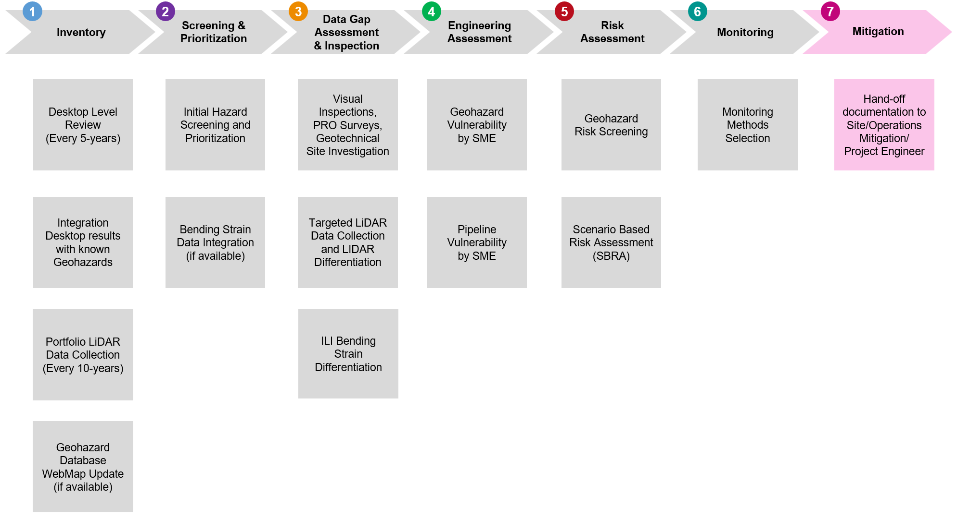

Mitigation measures can be implemented as temporary or permanent strategies. Temporary mitigation measures reduce the risk to the pipeline associated with the geohazards but cannot eliminate the risk. An example of a temporary mitigation measure is excavation of an affected pipeline section to relieve strain accumulation in the pipe. Temporary mitigation strategies should be combined with monitoring for both the active geohazard threat and the pipeline. Permanent mitigation measures should be designed to effectively eliminate the geohazard as a threat. An example of a long-term mitigation is pipeline rerouting.

# GMP Roles and Responsibilities

The Global GMP Organization Chart is shown on *Figure 3‑1* and a brief description of GMP Global Roles & Responsibilities are shown in this section below. Additional information will be included in *GMP RACI Chart (*[*Appendix A*](https://teamwork3.exxonmobil.com/sites/GlobalGMP/Shared%20Documents/GMP%20Toolkit/GMP%20Manuals%20and%20Guidelines/GMP%20Manual/Appendix%20A%20GMP%20RACI)*, to be developed)*.

*Figure 3‑1*. Geohazard Management Program Global Organization Chart

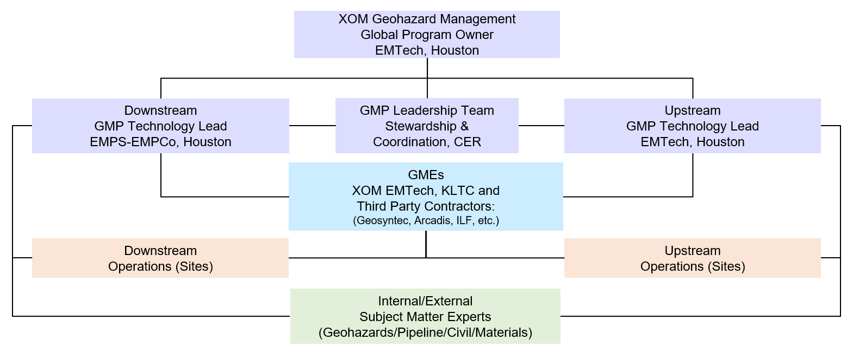

**Notes**:

|  |  |  |
| --- | --- | --- |
| Color Legend:  Lavender = Leadership / Management  Beige= Operations\Sites Representative  Blue = Geohazard Management Engineers  Green = Subject Matter Experts | CER = Cold Eyes Review  EMPCo = ExxonMobil Pipeline Company  EMPS = ExxonMobil Product Solutions  EMTech = ExxonMobil Technology and Engineering | ILF = ILF Consulting Engineers  KLTC = Kuala Lumpur Technology Center  GME = Geohazard Management Engineer  GMP = Geohazard Management Program |

Global Program Owner – Geohazard Management

The GMP is owned and stewarded by ExxonMobil Technology and Engineering (EMTech). The EMTech Geohazard Management Global Program Owner (Geohazard Management GPO) develops the global GMP strategy and sustainability plan and ensures the GMP is implemented and executed effectively and remains up to date. The Geohazard Management GPO engages globally in GMP technical support (CER, QA/QC), program enhancements, training, and mentoring.

GMP Leadership Team

The GMP Leadership Team includes Geohazard Management GPO, Upstream & Downstream GMP Technology Leads, and Principal Geotechnical Engineer, Principal Pipelines & Risers Engineer for Operations & Integrity and EMTech/ EMPCo PLR/Civil/Integrity Assurance Managers/Supervisors. The GMP Leadership Team takes an active role by establishing clear goals and priorities for GMP implementation; providing the necessary resources to implement and manage the GMP; and developing roles, responsibilities, and approval authority for the program. The GMP Leadership Team is ultimately responsible for the effectiveness/efficiency of GMP implementation & development.

Upstream GMP Technology Lead

The Upstream GMP Technology Lead is responsible for project management and overall coordination of GMP development, and implementation for Upstream Sites with support and guidelines from Geohazard Management GPO. The Upstream GMP Technology Lead maintains the sustainability of the program for Upstream Sites, and conducts/facilitates GMP training and refreshers for the Global GMP team.

Downstream GMP Technology Lead

The Downstream GMP Technology Lead is responsible for overall coordination of GMP development and implementation for Downstream Operational Areas within EMPS and maintains the sustainability of the program for Downstream. The Downstream GMP Technology Lead also contributes to program enhancements including tool revisions and documentation updates.

Geohazard Management Engineers

Geohazard Management Engineers (GMEs) (i.e., internal XOM EMTech, KLTC or Third-Party Contractors form Geosyntec, Arcadis, ILF, etc.) are responsible for implementing and facilitating the *Stages 1 – 7* work described in this GMP Manual, including developing inspection plans, identifying geotechnical natural forces threats, evaluating pipeline vulnerabilities from the ground movement, detailed engineering assessments, and developing monitoring plans for pipeline locations in collaboration with Operations/Site Representatives. GMEs also drive program development by coordinating other program activities (e.g., site reconnaissance, geotechnical or geophysical investigations, remote sensing data collection, ILI bending strain review, etc.), assisting Operations/Sites in developing Emergency Response Plans (ERPs) where required, providing updates to the GMP Technology Lead, and making continuous improvements to the GMP.

Subject Matter Experts

Subject Matter Experts (SMEs) are responsible provide expertise as needed and requested by the GMP Technology Lead or/and Geohazard Management GPO. SMEs advise and support GMEs on program components, including screening engineering assessments, monitoring requirements and mitigation selection. The SMEs also support Operations/Sites in designing engineering controls. The team is composed of internal engineering (EMTech WCP/Civil/Materials) and supplemental contracting resources (i.e., Geosyntec Consultants, Arcadis US Inc, ILF Consulting Engineers, etc.)

Lead Operations/Site Representative

Working in close contact with a GME, the Lead Operations/Site Representative is responsible for providing input data for GMP evaluation and coordinating alignment with Operations\Sites while progressing through the GMP stages, including inspections, monitoring, and mitigation activities. For EMPS Sites GMEs are responsible for alignment meeting coordination and data input collection through direct collaboration with Lead Operations/Site Representative.

Risk Facilitator /SSHE Team

The Certified Risk Facilitator/Risk Advisor from SSHE Team is responsible for the risk screening/assessment evaluation leveraging input and guidance from GMEs and GMP SMEs. The SSHE Team is also engaged in support inspection /mitigation activities by advising on necessary environmental permits or agreements.

Water Crossing GPO/ Technology Lead

GMP technology leads are responsible to engage/consult/inform Water Crossing GPO or/and WCP Technology Lead (Upstream or Downstream as needed) when the riverbank/slope stability concerns (e.g. unstable slopes such as landslides/ landslips) are identified that requires hydrotechnical assessment or/and hydrotechnical monitoring/mitigation expertise.

Site POC /Lead PIE/ GPO FIMS 03

Site country/project Point-of-Contact (POC) or lead Pipeline Integrity Engineer (PIE) can be engaged/consult during the GMP screening /assessment/monitoring stages as needed to gather required pipeline or/and site data or aligned on the GMP results/recommendations. For the Upstream sites the GPO FIMS 03 may be informed about locations where the ERPs or/and mitigation activities are recommended/planned/scheduled.

PODS / GIS Lead Contact

The Pipeline Open Data Standard (PODS) Leads and/or GIS Leads are responsible to support maintenance/sustainment of GMP Inventory Database, perform regular updates of GMP Inventory Database as new GMP hazards are identified, known hazards are reevaluated, or new data become available.

# Data Management

## Quality Control and Quality Assurance (QA/QC)

Quality Control and Quality Assurance (QA/QC) is an important process in providing accurate assessments. QA/QC are integrated into the GMP to help ensure accurate and consistent assessments provided to the customer. GMP Technology Leads, and GMEs should conduct QA/QC for GMP deliverables (*Stages 1 – 7*), leveraging QA/QC checklists to validate input data/assumptions and output results. The QA/QC process includes but not limited to accuracy spot checks, complete verification of all major assumptions, decisions on applied methods/methodology used for assessments, and review of SME results/recommendations.

## Documentation

Data gathered, collected or/and generated during all Stages of GMP is maintained in the GMP database and updated every time when new information is available. Worksheets, notes, photos, reports, and SME recommendations obtained during all GMP evaluation stages should be also kept in the GMP LAN folders for *EMPS*and *Upstream* as applicable.

If there is no restriction with data storage or/and sharing across XOM, then the [*PL-2275*](https://ishareteam2.na.xom.com/sites/empcolib/Forms/EMPCo%20GeoTech%20Data%20Submission%20Form.docx) needs to be completed when soil/ survey/ geotechnical data or reports become available. The geotechnical data or/and reports also needs to be uploaded to the [*Site Geotechnical Information*](https://ishareteam3.na.xom.com/sites/eng/EngTechInfo/_layouts/15/start.aspx#/Site%20Geotechnical%20Information/Forms/AllItems.aspx)SharePoint. Note some of the Sites (example Indonesia) required additional controls for the data storage and **should NOT** be uploaded to [*Site Geotechnical Information*](https://ishareteam3.na.xom.com/sites/eng/EngTechInfo/_layouts/15/start.aspx#/Site%20Geotechnical%20Information/Forms/AllItems.aspx)SharePoint.

# Program Effectiveness

## Review Process

The primary methods for assessing and managing the effectiveness of the WCP are self-assessments (i.e., tracking WCP progress over time) and reviews with the WCP Leadership Team. This includes inspection and assessment metrics reviewed at reporting meetings or meetings with Leadership Team.

## Program Updates

The WCP Program Documentation (Manuals, Guidelines, RPs, Technical Guides & Procedures), should be regularly evaluated for updates and changes. Changes should be documented in the change log/revision table for each document.

## Performance Measures

The performance of the GMP is measured annually through reporting leading and lagging indicators via the GMP Score Card as shown in *Table 5‑1* below. Leading and lagging indicators are designed to measure how the program identifies geohazards before and after they become potential pipeline integrity conditions, respectively. Score card target goals will be established once the GMP is considered mature (i.e., 5-years from deployment). During the five initial years, the score card shall include annual indicators for all previous years for performance tracking.

Table 5‑1. Geohazards Management Program Score Card

|  |  |
| --- | --- |
| Leading Indicators | Lagging Indicators |
| Number of potential geohazard locations reported by operations or geotechnical field investigations | Number of bending strain/ movement conditions associated with potential landslides (including those located at water crossing banks) requiring field investigations |
| Number of potential geohazards identified by the water crossing program (i.e., riverbank slope stability concerns) | Number of pipelines bending strain/ movement conditions associated with man-made excavations (i.e., backfills) |
| Number of landslides identified via desktop review of remote sensing materials, including regional and targeted LiDAR | Number of pipelines bending strain/ movement conditions requiring pipeline repairs of any type |
| Number of other potential geohazards identified by the GMP, including ground subsidence, seismic hazards, and special cases | Number of pipeline bending strain/ movement conditions in “monitoring” list |
| Number of geohazards in “monitoring” stage |  |

Acronyms and Abbreviations

ADB Advisory Bulletin

ALARP As Low as Reasonably Practicable

ASCE American Society of Civil Engineers

API American Petroleum Institute

ASD Allowable Stress Design

ASME American Society of Mechanical Engineers

AS/NZS Australia Standards/New Zealand Standard

BSI British Standards Institute

CER Cold Eyes Review

CFR Code of Federal Regulations

CSA Canadian Standards Association

CSC Compressive Strain Capacity

DEM Digital Elevation Model

DOT United States Department of Transportation

DOC Depth of Cover

EIG-03 FIMS Equipment Integrity Guides – Pipelines Manual

EMGP ExxonMobil Global Projects

EMI Electromagnetic Induction

EMPCo ExxonMobil Pipeline Company

EMPS ExxonMobil Product Solutions

EMTech ExxonMobil Technology and Engineering

ERB Energy Regulator Bulletin

FEA Finite Element Analysis

FFS Fitness for Service

FIMMS Facilities Inspection and Maintenance Management System

FIMS Facility Integrity Management System

FOF Frequency of Failure

FOS Factor of Safety (for slope stability)

GIS Geographic Information System

GME Geohazard Management Engineer

GMOP Global Manufacturing OIMS Practice

GMP Geohazard Management Program

GP Global Practice

GPO Global Program Owner

GPR Ground-Penetrating Radar

HC Higher Consequence

HCA High Consequence Area

HCRM Higher Consequence Risk Matrix

HDD Horizontal Directional Drill

ID Unique Identifier

ILF ILF Consulting Engineers

ILI In-Line Inspection

INGAA Interstate Natural Gas Association of America

IMU Inertial Measurement Unit

InSAR Interferometric Synthetic Aperture Radar

ISO International Organization for Standardization

KLTC Kuala Lumpur Technology Center

LAN Local Area Network

LiDAR Light Detection and Ranging

LOC Loss of Containment

OD Outside Diameter

OIMS Operations Integrity Management System

PHMSA Pipeline and Hazardous Materials Safety Administration

PGA Peak Ground Acceleration

PGD Permanent Ground Deformation

PGV Peak Ground Velocity

PIE Pipeline Integrity Engineer

POC PLR Point-of-Contact for Upstream Sites

PODS Pipeline Open Data Standard

POF Probability of Failure

PRCI Pipeline Research Council International

QA/QC Quality Assurance/Quality Control

RAM Risk Assessment and Management Manual

RP Recommended Practice

ROW Right-of-Way

SA Shape Arrays

SAA Shape Acceleration Arrays

SBA Strain-Based Assessment

SBD Strain-Based Design

SBRA Scenario Based Risk Assessment

SDL Strain Demand Limit

SI Slope Inclinometers

SME Subject Matter Expert

SMYS Specified Minimum Yield Strength

SSHE Safety, Security, Health, and Environment

SWL Seismic Wave Loading

TSC Tensile Strain Capacity

TMEE Technical Manual Exxon Engineering

TRM-03 FIMS Pipeline Technical Reference Manual

Upstream ExxonMobil Upstream Company

US or USA United States of America

USACE US Army Corps of Engineers

USGS United States Geological Survey

WCP Water Crossing Program

WOF Weather-Related and Outside Forces Threats

WT Wall Thickness

XOM ExxonMobil Corporation

Glossary

| **Term** | **Definition** |
| --- | --- |
| As Low as Reasonably Practicable (ALARP) | A risk acceptance review process that considers the best use of resources compared to the degree of risk reduction. ALARP involves asking the question: "What else can be done to further reduce the risk?" Reaching ALARP is the point at which the resources expended to further reduce risk are significantly disproportionate to the reduction in risk. |
| Bending Stress | Internal or compressive longitudinal stress developed in response to curvature induced by an external force |
| Channel Avulsion | The rapid abandonment of a river channel and formation of a new river channel, normally leaving an oxbow lake |
| Channel Degradation | The slow lowering of a channel bottom, usually due to a limited sediment supply upstream or increased discharge within the channel |
| Channel Migration | The gradual movement and winding of a river over time |
| Consequence | The expected negative result of the element or system of interest if exposed to a given threat |
| Consequence Analysis | The process of estimating the type and severity of potential effects resulting from incident outcomes of an event scenario independent of the frequency or probability. |
| Compressive Strain Capacity (CSC) | CSC is the strain capacity in compression. |
| Decision-Making Process | The process of evaluating decision options and deciding what, if any, options will be implemented to further reduce or mitigate risk. |
| Deposition | The physical process by which sediments, soil, and rock are added to a landform. |
| Depth of Cover (DOC) | The distance between the top of the pipeline and the surface of the ground above the pipeline. Minimum DOC represents the least amount of ground cover above the pipeline. |
| Duration-based Hazard | A time-dependent hazard when small changes occur over a long period of time that may include several small events, where ground movement or development of the hazard is measured in inches per year. |
| Erosion | The permanent removal of soil and rock by natural forces, such as water flow through a channel. |
| Event-based Hazard | A time-independent hazard when changes may occur in a single event, such as an earthquake, fault rupture, sinkhole formation, or flood, where the ground movement is measured in feet per second. |
| Factor of Safety (FOS) | In the context of slope failure, FOS is the ratio of the resisting forces to driving forces. |
| Fatigue | The phenomenon leading to facture of a material under repeated or fluctuating stresses having a maximum value less than the tensile strength of the material. |
| Fault | A fracture of the Earth’s crust defined by planes or rupture zones. |
| Frequency of Failure (FOF) | The number of historical occurrences of an event per unit of time or per demand (opportunity). Frequency > 0/yr. |
| Gas | Natural gas, flammable gas, or other that is toxic or corrosive. |
| Geohazard | A naturally occurring or human-triggered geologic process that has caused, or may result in, damage to the operation of a pipeline or associated facility or may impede the operation of a pipeline or associated facility. |
| Geohazard Vulnerability | Susceptibility of slope (ground) to fail during the geohazard events. Often expressed as factor-of-safety (FOS). |
| Geomorphology | The study of the origin and evolution of geohazards (such as landslides), which includes the physical, chemical, and biological processes at or near the surface of the Earth. |
| Geotechnical Study | The study of soil force interactions through engineering methods. |
| Geotechnical Hazard | A hazard to a pipeline that results from ground movement that creates permanent ground deformation (PGD) or associated with wave propagation phenomena or seismic wave loading (SWL). |
| Hazard | A potential source (chemical, physical, or biological) of harm to people, property, or the environment |
| Hazard Evaluation | The process of identifying what could go wrong, harm that could result, and the safeguards that are in place to develop a hypothetical sequence of events (scenario) that might lead to an incident. |
| Hazard Identification | The process of identifying the hazards associated with a given operation, activity, or design. |
| Hazardous Liquid | Petroleum, petroleum products, anhydrous ammonia, or ethanol. |
| High Bank | A transition point from steeper channel bank slope to a milder slope of adjacent floodplain. |
| High Consequence Area (HCA) | High consequence areas, as defined in 49 CFR Part 195.450, include: 1) commercially navigable waterways; 2) high population areas; 3) other populated areas; and 4) unusually sensitive areas (e.g. drinking water supplies, ecological sensitive areas). |
| Hydrotechnical Hazard | A hazard to a pipeline that results from changes in the stream channel and is usually associated with flowing water from streams or tidal currents. |
| Hydrotechnical Study | The study of hydraulic force interactions through engineering methods. |
| Inertial Measurement Unit (IMU) | An electronic device that measures and reports a body's specific force, angular rate, and sometimes the orientation of the body, using a combination of accelerometers, gyroscopes, and sometimes magnetometers. In the context of this report, an in-line inspection tool. |
| Karst | Areas with substrates that are subject to solution and erosion due to the movement of water through them creating voids in the subsurface. |
| Landslide | The naturally occurring or human-caused downward (or downslope) movement of a mass of soil or rock due to gravity. The term “landslide” encompasses a wide variety of processes that result in the downward movement of soil or rock. These materials may move by falling, toppling, sliding, spreading, or flowing. |
| Likelihood | An expression for the relative probability or expected frequency of the incident occurrence |
| Mitigation | Actions taken to reduce the consequences associated with a specific risk scenario/event or reduce the frequency of its occurrence. |
| Normal Loading Slope Failure | A slope failure scenario that may occur without a slope saturation by flood. |
| Permafrost | Permanently frozen layer of earth present in cold regions. |
| Permanent Ground Deformation (PGD) | PGD generally refers to irrecoverable soil displacement due to faulting, landslide, settlement or liquefaction induced lateral spreading. In this document, PGD is limited to permanent soil deformation due to bank slope failure. |
| PHMSA Significant Incident | A pipeline-related incident as defined by PHMSA as including one or more of the following conditions: 1) Fatality or injury requiring in-patient hospitalization; 2) $50,000 USD or more in total costs, measured in 1984 dollars; 3) Highly volatile liquid releases of 5 barrels or more or other liquid releases of 50 barrels or more; 4) Liquid releases resulting in an unintentional fire or explosion. |
| Pipeline Integrity Management Program (IMP) | A workflow process that evaluates the mechanical threats to a pipeline throughout the asset life cycle. |
| Pipeline Vulnerability | Susceptibility of a pipeline to be damaged by natural hazard (e.g. geohazard). |
| Precipitation | Rain or snow. |
| Probability of Failure (POF) | The expression for the likelihood of occurrence of an event sequence, during an interval of time, or the likelihood of success or failure of an event on demand. Probability ranges from 0 to 1. |
| Rapid Draw Down (RDD) Slope Failure | A slope failure condition where additional weight of soil saturation is left in a slope after a flood recedes rapidly. |
| Risk | A function of the likelihood of an unwanted incident combined with the severity of its potential consequences |
| Risk Analysis | The process of developing an estimate of risk based upon hazards and exposures. |
| Risk Assessment | The process of judging the significance of risk and determining whether further risk reduction is warranted. |
| Risk Determination | The process of combining the results of Consequence and Frequency analysis into a single descriptor of risk (i.e., Risk Category on the Risk Matrix). |
| Risk Matrix | A knowledge-based, qualitative tool used to systematically evaluate and communicate the potential frequency and severity of a risk scenario in a consistent manner. The primary tool for the determination of risk within ExxonMobil is the ExxonMobil Risk Matrix |
| Rotational slide | A slide where its movement occurs along a circular slip surface and dis-placement is primarily described by a vector tangent to the radius of the circular slip surface. |
| Scheduled Monitoring | Monitoring used to observe small changes over time by designating a specific maximum duration between inspections. |
| Saturation (of soil) | A condition that occurs when all the pore space is occupied by water. |
| Scour | The temporary removal of soil or rock by natural forces such as water flowing through a channel. |
| Seepage | Seepage is the movement of water in soils. Seepage depends on several factors, including permeability of the soil and the pressure gradient. |
| Seismogenic Fault | A fault capable of generating earthquakes |
| Shear Strength | Degree of resistance of a material to applied shear stresses. |
| Shear Zone | Area along which landslide shear strains are concentrated. |
| Sinkhole | A spherical, ellipsoidal, or tubular shaped depression that typically develops in karst areas either naturally in relatively soluble evaporate deposits (salt and gypsum) and carbonate rocks (limestone and dolomite) or anthropogenically through processes that accelerate the dissolution of these deposits. |
| Slide | A landslide that develops along a distinct rupture surface or shear zone. |
| Sliding | A shear failure in which a surficial portion of the embankment moves downslope. If such failure becomes progressively larger, it may represent a threat to embankment stability. |
| Slip Surface | Discrete surface where shear movements may occur. May also be called failure surface. |
| Soil Consistency | The strength with which soil materials are held together or the resistance of soils to deformation and rupture. |
| Soil Liquefaction | Reduction of the strength of saturated soils typically caused by seismically induced ground motions but could also develop following construction-equipment-induced vibrations. |
| Specified Minimum Yield Strength (SMYS) | The specified minimum yield strength for steel pipe manufactured in accordance with a listed specification such as American Petroleum Institute (API) 5L. |
| Stable Bank Slopes | Stable bank slopes are identified by lack of erosion at water crossing or location of concern. Often identified by well vegetated banks. |
| Strain | The deformation of an asset caused by forces that may lead to a weakened pipeline and a loss of containment. Often used for geotechnical assessments of pipelines. |
| Strain Capacity | The strain level that a pipe segment can sustain without negative consequences. The negative consequences could be a leak, a rupture, or any other change of the physical characteristics of the pipeline that an operator may deem unacceptable. |
| Strain Demand | The level of strain imposed on a pipeline by its operational and environmental conditions (such as a landslide). |
| Strain Demand Limit (SDL) | An assigned upper limit that the strain demand is allowed to reach on a pipeline. |
| Stream | A watercourse that flows along an elongated path. A stream may be a large river or a small creek. |
| Subsidence | A time-dependent process, either natural or human induced, in which the ground surface lowers over time in response to subsurface weathering, compaction, collapse, settlement or removal of gas, liquid, solid matter. |
| Tensile Strain Capacity (TSC) | TSC is the strain capacity in tension. |
| Threat | Phenomenon that could potentially lead to damage or consequences, characterized by its intensity, spatial and temporal extent, conditions (initial and boundary) and contributing factors |
| Translational Slide | A slide whose movement can be primarily described with a single vector. |
| Trigger Monitoring | Monitoring used to observe changes after a singular, significant event. The event that triggers the inspection is defined by an engineering assessment. |
| Vulnerability | The probability of reaching a consequence or damage in the element or system of interest, conditioned on a given threat intensity |

Internal References

Forms and Resources

* PL-2275 EMPCo GeoTech Data Submission Form ([*PL-2275*](https://ishareteam2.na.xom.com/sites/empcolib/Forms/EMPCo%20GeoTech%20Data%20Submission%20Form.docx)*)*
* WCP Slope Stability Inspection Checklist ([*Form*](https://teamwork4.exxonmobil.com/sites/GlobalWCP/Shared%20Documents/WCP%20Toolkit/WCP%20Tools%20and%20Forms/Bank%20Stability))
* WCP Visual Inspection Checklist ([*Form*](https://teamwork4.exxonmobil.com/sites/GlobalWCP/Shared%20Documents/WCP%20Toolkit/WCP%20Tools%20and%20Forms/Inspection))

Company References

* Geohazard Management Program SharePoint (*[goto/globalgmp](https://teamwork3.exxonmobil.com/sites/GlobalGMP/Shared%20Documents/Forms/AllItems.aspx)*)
* Water Crossing Program SharePoint (*[goto/globalwcp](https://teamwork4.exxonmobil.com/sites/GlobalWCP/Shared%20Documents/Forms/AllItems.aspx?id=%2Fsites%2FGlobalWCP%2FShared%20Documents%2FWCP%20Toolkit)*)
* Site Geotechnical Information SharePoint ([*Site Geotechnical Information*](https://ishareteam3.na.xom.com/sites/eng/EngTechInfo/_layouts/15/start.aspx#/Site%20Geotechnical%20Information/Forms/AllItems.aspx)*)*
* Global Practices [*GP 59-01-01U*](https://ishareteam8.na.xom.com/sites/EMEPS/_layouts/15/DocIdRedir.aspx?ID=4MRYFQJJP6TF-679258695-1315) & [*GP 59-01-01M*](https://ishareteam8.na.xom.com/sites/EMEPS/_layouts/15/DocIdRedir.aspx?ID=4MRYFQJJP6TF-679258695-1909) Onshore Pipeline Design (Upstream & Midstream)
* Global Practices [*GP 59-01-02U*](https://ishareteam8.na.xom.com/sites/EMEPS/_layouts/15/DocIdRedir.aspx?ID=4MRYFQJJP6TF-679258695-1322) Seismic Design of Pipelines (Upstream)
* Global Practices [*GP 59-01-04U*](https://ishareteam8.na.xom.com/sites/EMEPS/_layouts/15/DocIdRedir.aspx?ID=4MRYFQJJP6TF-679258695-1326) Onshore Pipeline Geohazards Survey (Upstream)
* Global Practices [*GP 85-01-01U*](GPG) Geographic Information System Deliverables
* Global Practices [*GP 85-02-01U*](https://ishareteam8.na.xom.com/sites/EMEPS/_layouts/15/DocIdRedir.aspx?ID=4MRYFQJJP6TF-679258695-1470) GIS Data Management
* Global Practices [*GP 85-03-02U*](https://ishareteam8.na.xom.com/sites/EMEPS/_layouts/15/DocIdRedir.aspx?ID=4MRYFQJJP6TF-679258695-1474) Airborne Remote Sensing Data Acquisition (Upstream)
* FIMMS [*ROW Maintenance Program*](https://ishareteam2.na.xom.com/sites/empcolib/Manuals/FIMMS%20Manual/FIMMS%20-%20ROW%20Maintenance%20Program.pdf) (Downstream)
* FIMMS [*Aerial Patrol Inspection Program*](https://ishareteam2.na.xom.com/sites/empcolib/Manuals/FIMMS%20Manual/FIMMS%20-%20Aerial%20Patrol%20Inspection%20Program.pdf)(Downstream)
* FIMS [*Production Best Practices*](https://ishareteam2.na.xom.com/sites/PBP/Proprietary/PBP_FIMS.pdf)(Upstream)
* FIMS Equipment Integrity Guides - Pipelines ([*EIG-03*](https://ishareteam3.na.xom.com/sites/EMPC0849/Pipelines/2Technical%20Manuals%20and%20Reference%20Documents/EIG%2003.pdf)) Manual (Upstream)
* FIMS Pipeline Technical Reference Manual ([*TRM-03*](https://ishareteam3.na.xom.com/sites/EMPC0849/Pipelines/2Technical%20Manuals%20and%20Reference%20Documents/TRM-03_Final.pdf)) (Upstream)
* ExxonMobil Risk Assessment and Management Guide ([*TMEE-211*](https://ishareteam5.na.xom.com/sites/TKMENG061/Public%20Library/Risk%20Assessment%20and%20Management%20Guide.pdf))
* ExxonMobil Risk Matrix Application Guide ([*TMEE-330*](https://ishareteam5.na.xom.com/sites/TKMENG061/Public%20Library/Risk%20Matrix%20Application%20Guide.pdf))
* ExxonMobil Global Projects (EMGP) Risk Assessment and Management Manual ([*RAM*](https://ishareteam2.na.xom.com/sites/GP-OIMS/GPOIMSDocs/02%20Identifying,%20Assessing,%20Mitigating%20and%20Accepting%20Risk/1%20System%20Documents/RAM%20Manual/EMGP_RAM_Manual_-_Rev%20(3).pdf))
* ExxonMobil Response Guidelines to Extreme Weather Events and Outside Force Threats to Pipeline Integrity and Associated Facilities ([*XOM Response Guidelines*](https://ishareteam2.na.xom.com/sites/empcolib/Manuals/Weather%20and%20Outside%20Forces%20Threat%20Management/Water%20Crossing%20Storm%20Response%20Guidelines/Water%20Crossing%20Program%20Storm%20Response%20Guidelines.pdf))
* EMPCo Pipeline Repair and Modifications Manual ([*Manua*](https://ishareteam2.na.xom.com/sites/empcolib/Manuals/Pipeline%20Repair%20and%20Modifications/Pipeline%20Repair%20and%20Modifications.pdf)*l)*

External References

*[1]* API (2017). Managing Hydrotechnical Hazards for Pipelines Located Onshore or Within Coastal Zone Areas, American Petroleum Institute API RP 1133 2nd edition, December 2017.

*[2]* API (2019). Managing System Integrity for Hazardous Liquid Pipelines. American Petroleum Institute API RP 1160 3rd edition, February 2019. Reaffirmed March 2024

*[3]* API (2021). Fitness-For-Service. American Petroleum Institute API RP 579 4th edition, December 2021.

*[4]* API (2024): Pipeline Integrity Management of Landslide Hazards. American Petroleum Institute API RP 1187 1st edition, August 2024.

*[5]* ASCE (1984). Guidelines for the Seismic Design of Oil and Gas Pipeline Systems, Committee on Gas and Liquid Fuel Lifelines. American Society of Civil Engineers Committee on Gas and Liquid Fuel Lifelines, New York, NY.

*[6]* AS/NZS (2018). Pipelines - Gas and Liquid Petroleum. Part 1: Design & Construction. AS/ NZS 2885. Australian/New Zealand Standard, 2018.

*[7]* ASME (2022). Managing System Integrity for Gas Pipelines, American Society of Mechanical Engineers, ASME B31.8S – 2022.

*[8]* BSI (2015). Petroleum and natural gas industries - Pipeline transportation systems BSI BS EN 14161:2011 + A1 (2015): (ISO 13623:2009 modified). British Standards Institution. European Standard. Approved by CEN (European Committee for Standardization). Amended AMD: June 30, 2015.

*[9]* BSI (2019). Guide to Methods for Accessing the Acceptability of Flaws in Metallic Structures. British Standards Institution. BS 7910:2019, Published December 31, 2019.

*[10]* CER (2020). CER SA-2020-01: Canada Energy Regulator (CER) Safety Advisory SA2020-01 – Girth Weld Area Strain-Induced Failures: Pipeline Design, Construction, and Operation Considerations.

*[11]* CSA (2019). Oil and Gas Pipeline Systems. CAN/CSA Z662-19. Canadian Standard Association Group. CAN/CSA Z662.

*[12]* ERB (2014). Alberta Energy Regulator Bulletin, Enhanced Monitoring of Pipeline Water Crossings, [*ERB-2014-12*](https://static.aer.ca/prd/documents/bulletins/AER-Bulletin-2014-12.pdf)April 10, 2014.

*[13]* ERB (2019). Alberta Energy Regulator Bulletin, Pipeline Integrity Management Programs Must Consider Slope Movement, [*ERB-2019-28*](https://static.aer.ca/prd/documents/bulletins/bulletin-2019-28.pdf) November 7, 2019.

*[14]* Geosyntec (2019a). Pipeline Geohazard Management Program Development. Stage-Gate 1: Philosophy and Approach. Developed for EMPCo by Geosyntec Consultants, October 2019.

*[15]* Geosyntec (2019b). Pipeline Geohazard Management Program Development. Stage-Gate 2: Identification and Assessment Workflow. Developed for EMPCo by Geosyntec Consultants, November 2019.

*[16]* Geosyntec (2019c). Geohazard program Development workshop for ExxonMobil. December 2019.

*[17]* Geosyntec (2019d). Pipeline Geohazard Management Program Development. Stage-Gate 3: Classification and Decision-Making. Developed for EMPCo by Geosyntec Consultants. December 2019.

*[18]* Geosyntec (2023). Level 1 Geohazards Assessment, North American ExxonMobil Pipelines, Rev. 0. May 23, 2023.

*[19]* Guthrie, R. and Reid, E. (2018). Estimating landslide induced probability of failure to pipelines using a structured reductionist approach, Proceedings of IPC2018, 12th International Pipeline Conference, (2018) IPC2018-51876.

*[20]* INGAA (2020). Recommended Practice for Pipeline Integrity Management of Landslide Hazards prepared for Interstate Natural Gas Association of America (INGAA) JIP by Geosyntec/ Golder/CRES. August 2020.

*[21]* INGAA (2023). Guidelines for Management of Landslide Hazards for Pipeline developed for Interstate Natural Gas Association of America (INGAA) and a Group of Sponsors by Geosyntec Consultants Inc., and the Center for Reliability Energy Systems, LLC (CRES).

*[22]* ISO 20074 (2019). Petroleum and natural gas industry- Pipeline transportation systems - Geological hazard risk management for onshore pipeline, First edition July, 2019.

*[23]* O'Rourke M.J., Liu X. (2012). Seismic Design of Buried and Offshore Pipelines, MCEER-12-MN04 Report, November 28, 2012.

*[24]* PHMSA (2015a). [*PHMSA DOT 49CFR195*](https://www.phmsa.dot.gov/pipeline/annotated-regulations/49-cfr-195). Transportation of Hazardous Liquids by Pipeline, PHMSA, Department of Transportation (DOT).

*[25]* PHMSA (2015b). [*PHMSA DOT 49CFR192*](https://www.phmsa.dot.gov/pipeline/annotated-regulations/49-cfr-192). Transportation of Natural and Other Gas by Pipeline, PHMSA, Department of Transportation (DOT).

*[26]* PHMSA (2019a). [*PHMSA ADB 2019-01*](https://www.phmsa.dot.gov/sites/phmsa.dot.gov/files/2020-03/2019-07132.pdf). Pipeline Safety: Potential for Damage to Pipeline Facilities Caused by Flooding, River Scour, and River Channel Migration. Docket No. PHMSA–2019–0047, April 11, 2019.

*[27]* PHMSA (2019b). [*PHMSA ADB 2019-02*](https://www.phmsa.dot.gov/sites/phmsa.dot.gov/files/2020-04/2019-08984.pdf). Potential for Damage to Pipeline Facilities Caused by Earth Movement and Other Geological Hazards. Docket No. PHMSA–2019–0087, May 2, 2019.

*[28]* PHMSA (2022). [*PHMSA ADB-2022-01*](https://www.phmsa.dot.gov/sites/phmsa.dot.gov/files/2022-06/2022-11791.pdf) Pipeline Safety: Potential for Damage to Pipeline Facilities Caused by Earth Movement and Other Geological Hazards. Docket No. PHMSA–2022–0063, June 2, 2022.

*[29]* PIP CVS02010 (2016). Geotechnical Engineering Investigation Specification, standard by Process Industry Practices, March 2016.

*[30]* PRCI (2009). Guidelines for Constructing Natural Gas and Liquid Hydrocarbon Pipelines through Areas Prone to Landslide and Subsidence Hazards. Prepared for Pipeline Research Council International, L52292. 2009.

*[31]* PRCI (2017). Pipeline Seismic Design and Assessment Guideline. PR-268-134501. June 2017.

*[32]* PRCI (2018). Guidelines for Management of Geohazards Affecting the Engineering and Construction of New Oil and Natural Gas Pipelines. PR-616-164506. May 2018.

*[33]* PRCI (2019a). Guidance for Assessing Buried Pipelines after a Ground Movement Event. PR-350-164501. May 2019.

*[34]* PRCI (2019b). Use of Aerial LiDAR Data Collection for Geohazard Assessment. PR-680-183907. August 2019.

*[35]* PRCI (2021). Guidance on the Excavation and Backfill Procedures in Areas of Geo-hazards and High Axial Strain and Stress. PR-350-174515. February 2021.

*[36]* Sancio, R., Varela, P., Vance, D., Abdolmaleki, K. and Sen, M., (2020). September. Qualitative and Semi-Quantitative Model for Estimating the Probability of Failure at River Crossings. In International Pipeline Conference (Vol. 84454, p. V002T07A022). American Society of Mechanical Engineers.

*[**37]* Sen, M. and Hassanien, S. (2019). On Estimating Pipelines Reliability at Slope Crossings, Proceedings of the Asset Integrity Management – Pipeline Integrity Management Under Geohazard Conditions, AIMPIMG (2019) 1034.

*[38]* Silva F., Lambe T. W. and Marr W. A. (2008). Probability and Risk of Slope Failure. Journal of Geotechnical and Geoenvironmental Engineering. December 2008, Vol. 134, No. 12, pp. 1691–1699. DOI: 10.1061/(ASCE)1090-0241(2008)134:12(1691)

*[39]* USACE (2003). Slope Stability Engineer Manual, US Army Corps of Engineers, EM 1110-2-1902, October 2003.

*[40]* USGS (1999). Land subsidence in the United States, edited by Galloway D., Jones D. R. and Ingebritsen S.E., USGS Circular 1182, 177p. Available online at: [*https://pubs.usgs.gov/circ/circ1182/*](https://pubs.usgs.gov/circ/circ1182/)*.* Accessed March 2025.

*[41]* USGS (2019). Subsidence Susceptibility Map for the Conterminous U.S. Available online at: <https://www.usgs.gov/centers/community-for-data-integration-cdi/science/subsidence-susceptibility-map-conterminous-us#overview> from <https://www.sciencebase.gov/catalog/item/5cd2ea33e4b09b8c0b7a5c59> Accessed March 2025.

*[42]* USGS (2020). Karst Map of the Conterminous United States - 2020. Available online at: [*https://www.usgs.gov/media/images/karst-map-conterminous-united-states-2020*](https://www.usgs.gov/media/images/karst-map-conterminous-united-states-2020) from [*https://doi.org/10.5038/9781733375313.1003.* Accessed March 2025](https://doi.org/10.5038/9781733375313.1003.%20Accessed%20March%202025).

*[43]* USGS (2021a). Texas Gulf Coast Groundwater and Land Subsidence Program. [https://www.usgs.gov/centers/ot-water/science/texas-gulf-coast-groundwater-and-land-subsidence-program?qt-science_center_objects=0 - qt-science_center_objects](https://www.usgs.gov/centers/ot-water/science/texas-gulf-coast-groundwater-and-land-subsidence-program?qt-science_center_objects=0%20-%20qt-science_center_objects). Accessed in March 2025.

*[44]* USGS (2023). Hazard map from the 2023 50-state update of the National Seismic Hazard Model Project. Available online at: <https://www.usgs.gov/media/images/hazard-map-2023-50-state-update-national-seismic-hazard-model-project>. Accessed March 2025.

*[45]* USGS (2025a). U.S. Landslide Inventory and Susceptibility. USGS Landslide Hazard Program. Available online at: <https://www.arcgis.com/apps/webappviewer/index.html?id=ae120962f459434b8c904b456c82669d>. Accessed March 2025.

*[46]* USGS (2025b). U.S. Geological Survey. US Quaternary faults. Available online at: <https://usgs.maps.arcgis.com/apps/webappviewer/index.html?id=5a6038b3a1684561a9b0aadf88412fcf>. Accessed March 2025.

*[47]* USGS (2025c). Earthquake Hazards Program. Earthquake Catalog. Available online at: <https://earthquake.usgs.gov/earthquakes/search/>. Accessed March 2025.

*[48]* Varela, P., Cheng, S., Sancio, R., Cook, D., McKenzie-Johnson, A., and Koduru, S. (2022). A New GIS-Based Method to Estimate Annual Probability of Pipeline Failure Resulting from Landslides Based on Actual Failure Locations. In International Pipeline Conference (Vol.86564, p. V001T07A002). American Society of Mechanical Engineers.

Appendix A. Geohazard Management Program RACI

Version 1 – TO BE DEVELOPED

Appendix B. Introduction to Geohazard Threats

Version 1 – March 2025

Appendix C. Hazard Classification

Version 1 – March 2025

Appendix D. Bending Strain Data Integration

Version 1 – March 2025

Appendix E. Level 2 Geohazards Investigations

Version 1 – March 2025

Appendix F. Slope Stability Assessment Manual

Developed by Water Crossing Program (WCP)

Version 1 – March 2025

Appendix G. Geohazard Monitoring Methods

Version 1 – March 2025

Appendix H. Geohazard Mitigation Guidelines

Version 1 – March 2025